Hamburg: Logistics hall let
Apex expands with space in the Garbe logistics hall, Glinde

Hamburg, 19 January 2023 — Business is booming for logistics firm Apex Internationale Spedition, and the firm needed more space than is available at its headquarters at Wilhelm-Bergner-Strasse 3 on the “Glinnkamp” industrial estate in Glinde. However, any additional space had to be located near the present location. Apex found what it required directly across the road at number 4, newly vacated by Jungheinrich. It is part of a Garbe Industrial Real Estate complex. Grossmann & Berger, member of German Property Partners (GPP), brokered the lease on the 3,493 m² of logistics facility and some 376 m² of office space. “The tenant’s requirements and the site of the premises we brokered were a perfect match,” said Bertram Schubert, G&B consultant for industrial and logistics real estate.

The hall has three dock levellers; it was built in 1979 and modernized in 2009/2011. In the medium term Garbe’s sustainability plans envisage upgrading the existing systems to LED lighting. At the new site Apex, an owner-operated forwarding company with daily services to more than ten European destinations, also has use of an outside area of around 1,335 m² and 26 car parking spaces. Apex was founded in 1981 and belongs to the family-run Heinz Gruppe; it has an office in Bremen and maintains an office plus adjacent storage facility in both Wang and Unterschleißheim. The firm has been using the new space since the end of November.

Type of use | Hallenfläche, Bürofläche
Stadt | Glinde
Straße | Wilhelm-Bergner-Straße 4
Vermieter | Garbe Industrial Real Estate GmbH
Käufer | Apex GmbH Internationale Spedition
Vermittler | Grossmann & Berger GmbH
Gesamtnutzfläche  Hallenfläche  Bürofläche | ca. 3.869 m²  - ca. 3.493 m²  - ca. 376 m²
Grundstück | ca. 35.128 m²

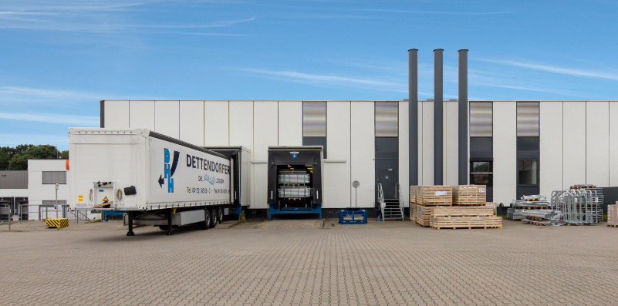 | Photo:  At the end of 2022 Apex International Spedition became the new tenant of the logistics hall at Wilhlem-Bergner-Strasse 4 in Glinde.  Source: Grossmann & Berger GmbH
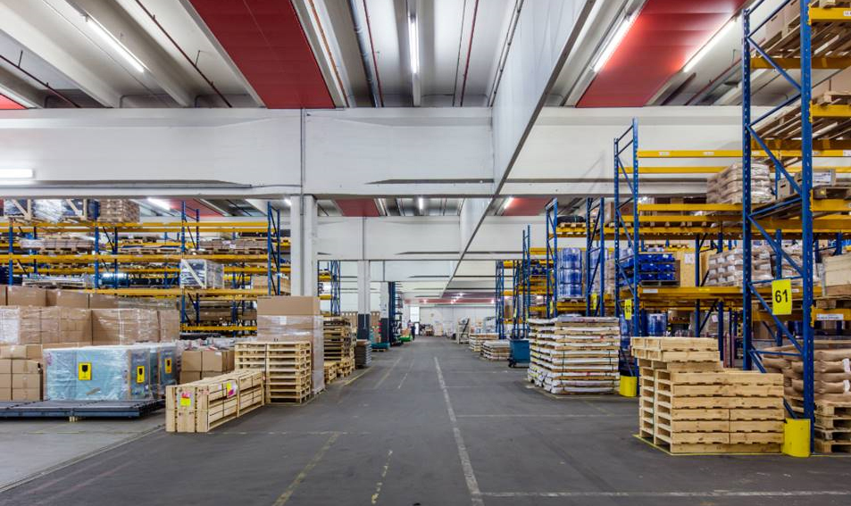 | Photo:  The logistics facility in the Glinde industrial estate is owned by Garbe Industrial Real Estate.  Source: Grossmann & Berger GmbH

Please consult our website for Grossmann & Berger’s data privacy policy. Here you will also be able to access our press kit and the associated Terms of Use. If in future you would prefer not to receive any more information from our press office please e-mail us at presse@grossmann-berger.de quoting as reference "Abmeldung aus Presseverteiler” / “Unsubscribe from press mailing list”.

