Hamburg: Industrial and logistics properties market, 1st quarter, 2023
Shortage of space acts in two ways – as brake and catalyst

Hamburg, 12 April 2023 – The role played by owner-occupiers on the office-letting market in Hamburg in the 1st quarter of 2023 was very small, but on the market for industrial and logistics space they were barely visible at all. They accounted for only 1 % of the 85,000 m² of take-up recorded to date. The overall result fell 32 % below the relatively good total posted for the same period a year before. “Companies want to move to different or larger premises, but often they are unable to find space that suits their needs. So the problem is not a lack of interest,” remarks Nico Beckmann, consultant for industrial and logistics real estate at Grossmann & Berger, member of German Property Partners (GPP). “In the face of rising energy costs and the increasing desire for properties that meet sustainability criteria, demand has, however, shifted even further towards new builds or premises that are as good as new. But if no land is available for development, nothing can be built.”

Market details:
- In the context of the sole owner-occupier transaction, Safran Helicopter Engines acquired a 6,000 m² plot of land on Spelterstrasse in the Nordport industrial estate. This specialist manufacturer of helicopter engines plans a new building with engineering and storage facilities plus a suite of offices.
- The dominant size category a year ago was that of 10,000 m² or more; take-up in this sector has now halved to 39,700 m². Between January and March 2022 Grossmann & Berger had recorded three agreements for more than 15,000 m² of space. In the same period a year later, there was not a single transaction involving a property of this size.
- The shortage of space has caused rents to skyrocket. The top price bracket, €5.51/m²/month or more, applied to 31 % of transactions at the end of March 2022, but this year Grossmann & Berger notes that 87 % of take-up falls into this sector of the market. At €8.00/m²/month, premium rents thus reached a new all-time high. The average rent also increased to €6.00/m²/month.
- Posting almost equal shares of the market, logistics and forwarding firms (38 %) and manufacturing/ industrial/craft trades (35 %) were the two most active sectors of industry.
- In terms of distribution of activity, three sub-markets were most heavily in demand: Hamburg North East and Hamburg South, each accounting for 27 % of take-up, and East Environs with a share of 25 %.

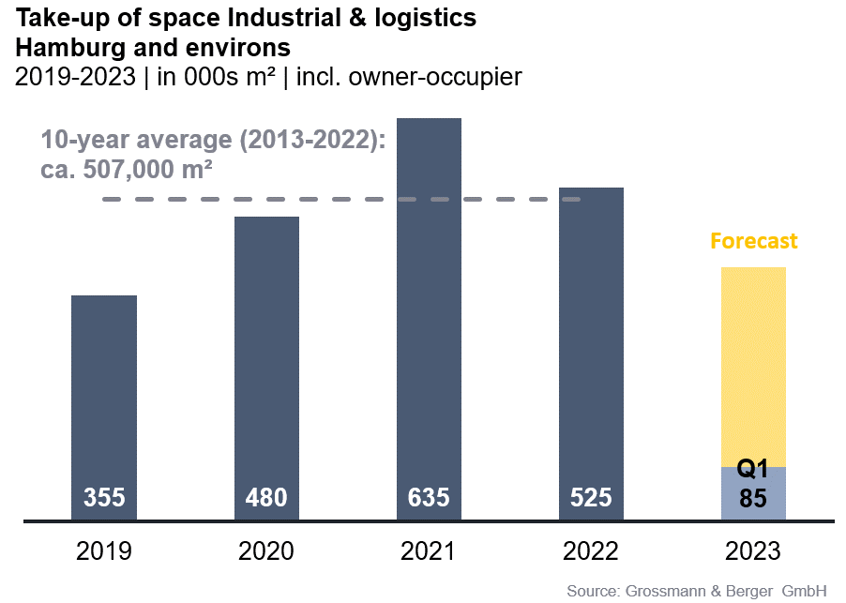
Industrial & logistics | Hamburg & environs | 2023 | Q1
Space take-up [m²] | 85,000
against prior yr [%] | -32.0
Ratio of owner-occupiers [%] | 1
against prior yr [percentage points] | -35
Premium rent [€/m²/month net of services] | 8.00
against prior yr [%] | +19.4
Average rent [€/m²/month net of services] | 6.00
against prior yr [%] | +9.1
Most popular sub-market | Hamburg North East, Hamburg South
Most popular sub-market [%] | 27
Industry with highest turnover | Logistics & forwarding
Industry with highest turnover [%] | 38

Selected top known transactions | industrial & logistics | Hamburg & environs | 2023 Q1
City | Road/street | Property/project | Tenant/owner-occupier | Floor area  [ca. m²]
Hamburg | Am Altenwerder Kirchtal 1-3 | “Prologis Park Hamburg Altenwerder” | Trading company | 14,600
Barsbüttel | Stemwarder Landstrasse 15a | Logistics hall | Logistics & forwarding | 13,600
Hamburg | Hamburg North-East | confidential | confidential | 11,400

Our Market report industrial and logistics properties Hamburg Q2 2023 in PDF format will be available in mid-year and can be downloaded from our website.

About Grossmann & Berger
Grossmann & Berger GmbH is one of the leading service providers in the business of selling and letting commercial and residential properties. Including its headquarters in Hamburg and locations in Berlin, Stuttgart and Munich, the group of companies consisting of Grossmann & Berger and E & G Immobilien has 22 local offices throughout Germany. Drawing on their comprehensive expertise in the real estate business, some 250 employees provide the full range of relevant services. They also benefit from the company’s more than 90 years standing in the industry. Grossmann & Berger belongs to HASPA Group and is a founding member of the national commercial real estate network German Property Partners (GPP).

Please consult our website for Grossmann & Berger’s data privacy policy. Here you will also be able to access our press portfolio and the associated terms of use. If in future you would prefer not to receive any more information from our press office please e-mail us at presse@grossmann-berger.de quoting as reference "Abmeldung aus Presseverteiler” / “Unsubscribe from press mailing list”.

