Hamburg: Industrial & logistics property market 1st-2nd quarters of 2022
Agreements for new-builds play major role in take-up and higher rents

Hamburg, 13 July 2022 – In the 1st half of 2022 the market for industrial and logistics space in Hamburg and the environs was dominated by new-builds. To date, nine agreements for premises offering more than 10,000 m² of space were signed; five of these, accounting for close to 100,000 m² of take-up, were signed off-plan and two were building starts for owner-occupiers, which added 33,500 m² to the total. “At present there is a shortage of available buildings in Hamburg. Demand is so high that many new-build developments are often fully let before they are completed. That in turn has an effect on rents,” says Felix Krumreich, consultant for industrial and logistics real estate at Grossmann & Berger, a member of German Property Partners (GPP). Take-up of space in the 1st half year totalled 250,000 m², equally divided between the 1st and 2nd quarters. The result was thus higher than both the five-year and the ten-year average of some 230,000 m². However, compared with the exceptional 1st half year of 2021 take-up of space was about 27 % lower.

Market details:
- The three biggest agreements signed in the 2nd quarter were concluded for new-build space. Whereas in 2021 34 % of take-up volume was concluded in the €4.51 to €5.00/m²/month price category, the focus of letting activity shifted year on year so that 46 % fell into to the €5.51/m²/month category (2Q2021: 31 %).
- This shift pushed both the average and premium rents up by more than 7.5 % each. At the end of June the premium rent was €6.90/m²/month, the average rent €5.60/m²/month.
- Owner-occupiers made up 27 % of the market in the 1st half year. At the same time, the number of such agreements was halved from thirteen to seven. “Buildings commissioned for owner-occupiers are considerably bigger than last year, because most contracts were signed by logistics firms and forwarders, whose businesses require large amounts of space per se,” says Krumreich.
- Year on year the proportion of agreements for properties sized 10,000 m² or more rose from 44 % to 66 %. All other size categories comprised less than 15 % of the market.
- Another agreement for over 20,000 m² was the biggest posted in the 2nd quarter. Online furniture dealer SoBuy Commercial is leaving its premises in Rahlstedt, formerly Globetrotter’s central warehouse, and renting 22,100 m² of storage space and 715 m² of offices in a new logistics development offered by Garbe Industrial Real Estate in Stapelfeld.
- Retail/wholesale and logistics & forwarding were the predominant industries, accounting, respectively, for 51 % of take-up (2Q2021: 26 %) and 40 % (2Q2021: 55 %). Retail/wholesale concluded six of the nine agreements for more than 10,000 m² of space, logistics and forwarding firms three.
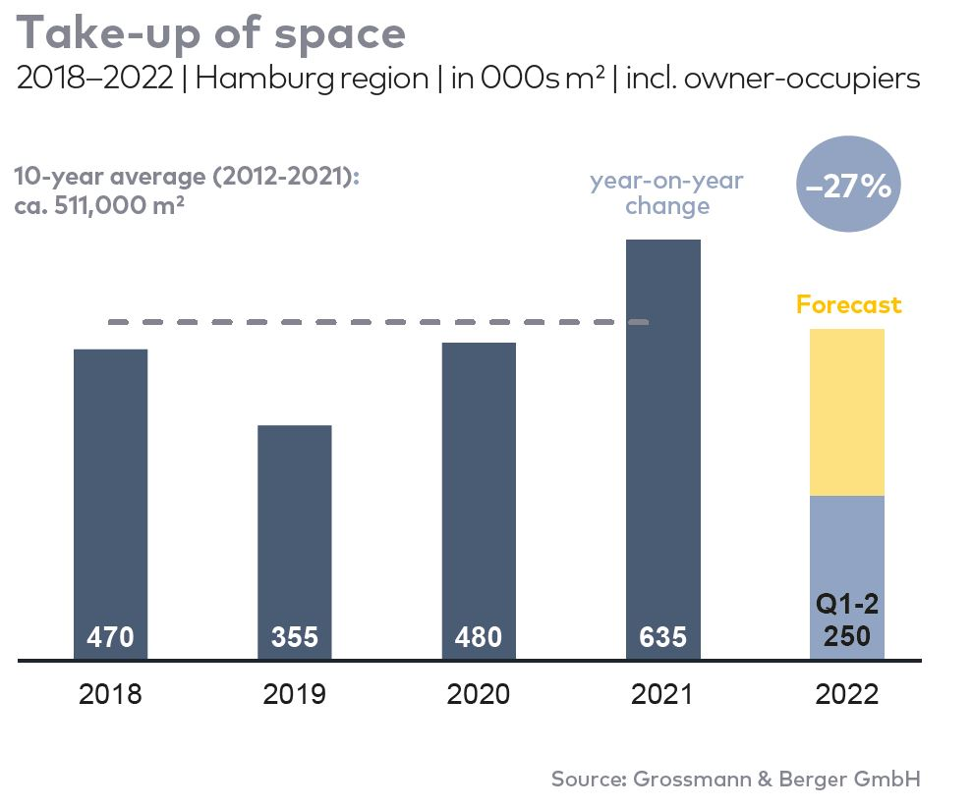
- Year on year the Hamburg South sub-market pulled ahead of Hamburg East to take 34 % of the market (2Q2021: 30 %). Among the reasons for this result are three large-volume agreements and the complete letting of space in the “Mach2 / Four Parx Hamburg” on Reiherstieg-Hauptdeich in Wilhelmsburg district.
Industrial, logistics | Hamburg and Environs | 2022 | Q1-2
Space take-up [m²] | 250,000
against prior yr [%] | -27
Ratio of owner-occupiers [%] | 27
against prior yr [percentage points] | +16
Premium rent [€/m²/month net of services] | 6.90
against prior yr [%] | +7.8
Average rent [€/m²/month net of services] | 5.60
against prior yr [%] | +7.7
Most popular sub-market | Hamburg South
Most popular sub-market [%] | 34
Industry with highest turnover | Retail/wholesale
Industry with highest turnover [%] | 51

Selected top transactions | industrial & logistics | Hamburg & environs | 2022 Q1-2
City | Road/street | Property/project | Tenant/owner-occupier | Floor area  [ca. m²]
Geesthacht | Düneberger Strasse 70 | Norddeutsche Teppichfabrik  (disused carpet factory) | Pfaff Logistik | 29,500
Hamburg | Reiherstieg-Hauptdeich  39-47 | “Mach2 / Four Parx Hamburg”  new-build logistics halls | JYSK | 24,000
Stapelfeld | Meiendorfer Amtsweg | Logistics new build | SoBuy Commercial | 22,100
Hamburg | Reiherstieg-Hauptdeich  39-47 | “Mach2 / Four Parx Hamburg”  new-build logistics halls | Bechtle | 18,800
Hamburg | Amadeus-Stubbe-Strasse | “Spectrum”, logistics new build | Fiege Deutschland (owner-occupier) | 18,500
Nützen | Kirchenweg 12 | “Panattoni-Park Hamburg Nord”  Halls 2 + 3 | The Quality Group | 17,600

New agreements are colour-marked

Our Market Survey Industrial & Logistics Hamburg 2022/Q2 in PDF format will shortly be available to download from our website.

About Grossmann & Berger
Grossmann & Berger GmbH is one of the leading service providers in the business of selling and letting commercial and residential properties in North Germany. Including its main office in Hamburg, the Company has 22 regional offices. This allows Grossmann & Berger to cover the entire North German market. In May 2021 the company was augmented by E & G Real Estate and
E & G Private Immobilien, so that Grossmann & Berger also operates in the two South German metropolitan areas of Stuttgart and Munich. Drawing on their comprehensive expertise in the real estate business, some 240 employees provide the full range of relevant services. They also benefit from the company’s more than 85 years standing in the industry. Grossmann & Berger belongs to the HASPA Group and is a founding member of the national commercial real estate network German Property Partners (GPP).

Please consult our website for Grossmann & Berger’s data privacy policy. Here you will also be able to access our press kit and the associated Terms of Use. If in future you would prefer not to receive any more information from our press office please e-mail us at presse@grossmann-berger.de quoting as reference "Abmeldung aus Presseverteiler” / “Unsubscribe from press mailing list”.

