Hamburg: Industrial and logistics properties market, 1st-3rd quarters, 2022
Shortage of space obliges tenants to rent new builds and drives up rates

Hamburg, 20 October 2022 – Large volumes at top-of-the-range rents – that neatly describes the agreements signed for industrial and logistics properties in Hamburg and its environs up until the end of September 2022. Agreements for large amounts of space comprised 70 % of take-up and in 43 % of agreements rents were high, at more than €5.51/m²/month. “To date, nine of the fourteen agreements for large amounts of space related to facilities in new-builds or good-as-new premises where rents were correspondingly high,” remarks Nico Beckmann, consultant for industrial & logistics properties at Grossmann & Berger, member of German Property Partners (GPP). “It is an absolute rarity to find empty space in an existing building. Therefore companies have to turn to developers and must be prepared for much longer planning periods than in the past. Strictly speaking, they have no choice but to focus on the few new buildings under construction, most of them in the environs of Hamburg.” Thanks to large-volume agreements, total take-up reached 400,000 m², and was thus higher than both the five-year and the ten-year average. But the shortage of space produced a result that was about a fifth lower than the record-breaking figure returned a year before. In view of the dearth of space and the fact that, apart from a couple of exceptions, all the space in new developments has been let, Grossmann & Berger expects the year to close with turnover approaching 500,000 m² at the most.

Market details:
- Owner-occupiers accounted for 26 % of the market (3Q 2021: 15 %). Their share of take-up climbed by 39 % to 104,000 m².
- In what was the biggest new agreement between July and September, Picnic, a Dutch online supermarket company, took 25,300 m² of hall space and 800 m² of offices as part of its bid to expand in Germany. On behalf of the company a joint venture made up of Garbe Industrial Real Estate and Graubner Holding is developing a new logistics centre for them in Kaltenkirchen. In the prior quarter, Picnic had already rented 14,800 m² of space in “Mach 2 / Four Parx Hamburg”.
- The large number of contracts for big, good-as-new premises propelled both average and premium rents 11 % above the levels noted at the end of September 2021.
- The wholesale/retail trade was the dominant sector at 56 %.
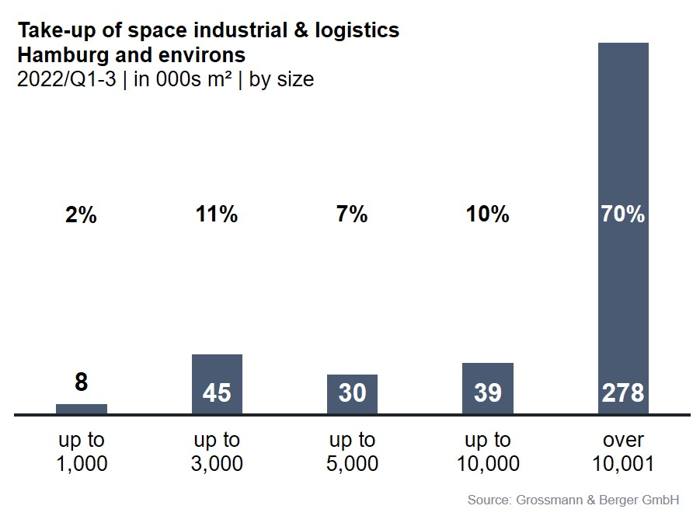
- Brisk market activity was noted in the sub-markets Hamburg South (25 %) and Hamburg East (18 %). Whereas up to the end of September 2021 take-up was concentrated in the city area (63 %), a year later it was far more evenly divided between the city (47 %) and the environs (53 %).
Industrial & logistics |  Hamburg & environs | 2022 Q1-3
Space take-up [m²] | 400,000
against prior yr [%] | -19
Ratio of owner-occupiers [%] | 26
against prior yr [percentage points] | +11
Premium rent [€/m²/month net of services] | 7.20
against prior yr [%] | +10.8
Average rent [€/m²/month net of services] | 5.80
against prior yr [%] | +11.5
Most popular sub-market | Hamburg South
Most popular sub-market [%] | 25
Industry with highest turnover | Trade/retail
Industry with highest turnover [%] | 56

Selected top transactions | industrial & logistics | Hamburg & environs | 2022 Q1-3
City | Road/street | Property/project | Tenant/owner-occupier | Floor area:  [ca. m²]
Stelle | Harburger Straße | Logistics centre | Aldi (owner-occupier) | 42,500
Geesthacht | Düneberger Strasse 70 | Norddeutsche Teppichfabrik (disused carpet factory) | Pfaff Logistik | 29,500
Kaltenkirchen | Werner-von-Siemens-Strasse 10 | New build logistics centre | Picnic | 25,300
Hamburg | Reiherstieg-Hauptdeich 39-47 | “Mach2 / Four Parx Hamburg”  new-build logistics halls | JYSK | 24,000
Stapelfeld | Meiendorfer Amtsweg | New build logistics centre | SoBuy Commercial | 22,100
New agreements are highlighted.

Our Market survey industrial & logistics Hamburg 2022/Q4 will appear in January 2023 and may be downloaded as a PDF file from our website.

About Grossmann & Berger
Grossmann & Berger GmbH is one of the leading service providers in the business of selling and letting commercial and residential properties in North Germany. Including its main office in Hamburg, the Company has 22 regional offices. This allows Grossmann & Berger to cover the entire North German market. In May 2021 the company was augmented by E & G Real Estate and
E & G Private Immobilien, so that Grossmann & Berger also operates in the two South German metropolitan areas of Stuttgart and Munich. Drawing on their comprehensive expertise in the real estate business, some 240 employees provide the full range of relevant services. They also benefit from the company’s more than 85 years standing in the industry. Grossmann & Berger belongs to the HASPA Group and is a founding member of the national commercial real estate network German Property Partners (GPP).

Please consult our website for Grossmann & Berger’s data privacy policy. Here you will also be able to access our press kit and the associated Terms of Use. If in future you would prefer not to receive any more information from our press office please e-mail us at presse@grossmann-berger.de quoting as reference "Abmeldung aus Presseverteiler” / “Unsubscribe from press mailing list”.

