Hamburg: Industrial and logistics properties market, 1st-4th quarters, 2022
Same pattern throughout 2022: dwindling availability, rising rents

Hamburg, 26 January 2023 – Take-up of industrial and logistics space in Hamburg and the environs closed the year at 525,000 m² and was thus higher than the ten-year average (507,300 m²) but at the same time 17 % lower than the record result of 2021. Agreements for more than 10,001 m² of space were the defining feature of the market. This size category accounted for 62 % of total take-up. “Because most of these contracts were signed off-plan in new developments, rents soared to record heights,” says Felix Krumreich, consultant for industrial and logistics real estate at Grossmann & Berger, a member of GPP. Correspondingly, the premium rent rose year on year from €6.40 to €7.50/m²/month. “Logistics companies and trading enterprises in Hamburg and the environs still have very well-stocked order books. However, in 2023 they could find it rather difficult to realize plans for expansion or to obtain extra space. The reason is that almost all the space in development projects has already been absorbed. Assuming, of course, that the global parameters remain unchanged.”

Market details:
- At the close of the year a quarter of take-up was attributable to owner-occupiers (4Q 2021: 12 %). Four of the 16 owner-occupier agreements were for more than 10,001 m² of space. The largest of these was signed in the 4th quarter when Edeka began construction of its new 16,800-square-metre “Fruchtkontor” fruit trading facility on Dessauer Strasse. At the site on Kleiner Grasbrook, food retailer Edeka plans to expand its existing fruit trading hall with the addition of a logistics hub for fresh fruit and vegetables from some 80 different countries and a banana ripening facility.
- The largest rental agreement in the 4th quarter was signed by Airbus to secure 30,000 m² of hall space in the Waltershof area of the port (Hamburg South sub-market) close to its manufacturing facility.
- From 2021 to 2022 the average rent rose by 9.4 % to €5.80/m²/month, an increase dwarfed by the 17.2 % growth of the premium rent.
- In 2022 the retail/wholesale sector of industry was predominant on the Hamburg market with 50 % of take-up (4Q 2021: 26 %). Companies from this sector accounted for ten of the 16 agreements for more than 10,001 m² of space. Logistics firms made up 33 % of the market (4Q 2021: 47 %).
- Hamburg South sub-market once again posted the biggest share of take-up with 29 % of the market at the end of 2022, following 27 % the year before. Hamburg East and North East Environs followed with 17 % and 15 % of the market respectively.

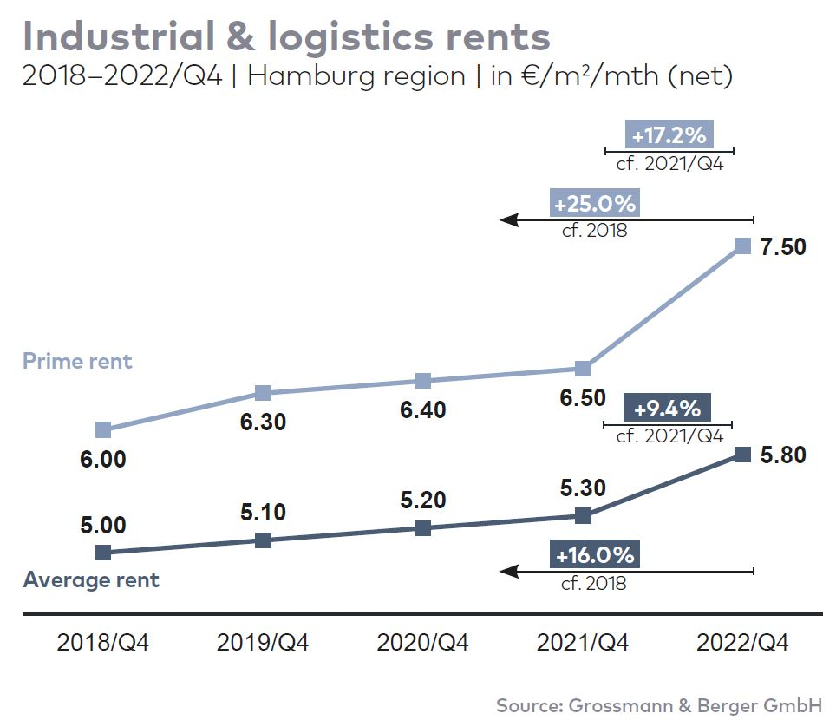
Industrial & logistics | Hamburg & environs | 2022 Q1-4
Space take-up [m²] | 525,000
against prior yr [%] | -17
Ratio of owner-occupiers [%] | 25
against prior yr [percentage points] | +12
Premium rent [€/m²/month net of services] | 7.50
against prior yr [%] | +17.2
Average rent [€/m²/month net of services] | 5.80
against prior yr [%] | +9.4
Most popular sub-market | Hamburg South
Most popular sub-market [%] | 29
Industry with highest turnover | Retail/wholesale
Industry with highest turnover [%] | 50

Selected top transactions | industrial & logistics | Hamburg & environs | 2022 Q1-4
City | Road/street | Property/project | Tenant/owner-occupier | Floor area  [ca. m²]
Stelle | Harburger Straße | Logistics centre | Aldi (owner-occupier) | 42,500
Hamburg | Hamburg South sub-market | Existing logistics centre | Airbus | 30,000
Geesthacht | Düneberger Strasse 70 | Norddeutsche Teppichfabrik (disused carpet factory) | Pfaff Logistik | 29,500
Kaltenkirchen | Werner-von-Siemens-Strasse 10 | New build logistics centre | Picnic | 25,300
Hamburg | Reiherstieg-Hauptdeich  39-47 | “Mach2 / Four Parx Hamburg”  new-build logistics halls | JYSK | 24,000
New agreements are highlighted

Our Market survey industrial & logistics Hamburg 2022/Q4 in PDF format will shortly be available to download from our website.

About Grossmann & Berger
Grossmann & Berger GmbH is one of the leading service providers in the business of selling and letting commercial and residential properties in North Germany. Including its main office in Hamburg, the Company has 22 regional offices. This allows Grossmann & Berger to cover the entire North German market. In May 2021 the company was augmented by E & G Real Estate and
E & G Private Immobilien, so that Grossmann & Berger also operates in the two South German metropolitan areas of Stuttgart and Munich. Drawing on their comprehensive expertise in the real estate business, some 240 employees provide the full range of relevant services. They also benefit from the company’s more than 85 years standing in the industry. Grossmann & Berger belongs to the HASPA Group and is a founding member of the national commercial real estate network German Property Partners (GPP).

Please consult our website for Grossmann & Berger’s data privacy policy. Here you will also be able to access our press kit and the associated Terms of Use. If in future you would prefer not to receive any more information from our press office please e-mail us at presse@grossmann-berger.de quoting as reference "Abmeldung aus Presseverteiler” / “Unsubscribe from press mailing list”.

