Berlin: Investment market, 1st quarter of 2023
Few transactions at the start of the year

Hamburg, 06 April 2023 – The market for investment in commercial properties in Berlin started the year slowly and by the end of the 1st quarter investors were still proceeding with caution. The volume of transactions closed at some €700m. Much of this result was due to the purchase of shares in the “KaDeWe” department store by Signa Prime Selection Compared with the first quarter of 2022, when results were skewed by the big-volume takeover of alstria by Brookfield Properties, the total has dropped by around 70 %.

“Few property investment transactions were concluded in Berlin during the first three months of the year. The national capital is thus in line with the rest of the country,” says Frank-D. Albers, managing director of Grossmann & Berger, member of German Property Partners (GPP). “In an uncertain market environment investors remain hesitant about making any moves. Many purchase processes are still “on hold” and investors are waiting until the price discovery phase has ended.” Albers’ forecast for the rest of the year is, “Berlin is and will remain an attractive macro-location for investors. As soon as a stable interest rate enables players to make more reliable calculations and the prices that buyers and sellers are willing to accept begin to converge, I am optimistic that the market will revive.”

Market details:
Note: Since the following figures are based on only 10 transactions, their information value is limited.
- Transactions falling into the price category of €100m or more accounted for around 51 % of the total traded. In this respect too, the sale of shares in the “KaDeWe” department store was a major boost. About 29 % of the transaction volume related to agreements signed at prices between €51m and €100m.
- Accounting for some 50 % of the volume, retail properties were the most traded class of asset. This unusually strong showing is likewise largely due to the sale of shares in the “KaDeWe”. Office properties followed with 21 % and mixed-use real estate with 13 % of the market.
- Specialist funds were very active and this buyer group accounted for around 54 % of the total traded.
- Among the vendors, listed property investment AGs/REITs were predominant with a market share of some 51 %.
- International investors were very active, accounting for about 69 % of turnover.
- Year on year prime yields have risen on all classes of asset: on offices yields grew by 1.20 percentage points to 3.8 %, on offices by 1.30 percentage points to 4.0 % and on industrial and logistics real estate by 0.6 percentage points to 3.8 %. These yields are estimated on the basis of only a small number of real reference cases.

Investment market | Berlin | 2023 | Q1
Transaction volume [€ millions] | 700
against prior yr [%] | -70
Proportion of international investors [%] | 70
Prime net yield, office [%] | 3.8
against prior yr [percentage points] | +1.20
Prime net yield, commercial buildings [%] | 4.0
against prior yr [percentage points] | +1.20
Prime net yield, logistics properties [%] | 3.80
against prior yr [percentage points] | +0.60
Strongest asset class | Retail
Strongest asset class [%] | 50
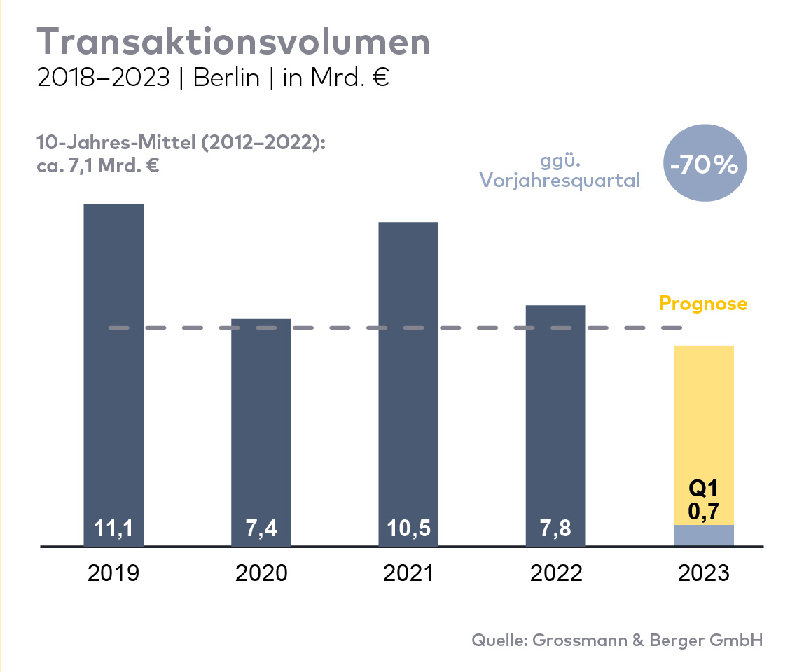

Selected top transactions | investments in Berlin | Q1 2023
Project/property  Street no. | Sub-market | Asset class | Buyer/investor | Vendor | Purchase price*  [approx. €m]
Kurfürstendamm 125 A | Periphery West | Offices | N. N. | Blackstone Group | confidential
Offices and medical practices building Mariendorfer Damm 159-161 | Periphery south | Offices | Imaxxam Asset & Portfolio Management | BR-NAS German Mittelstand Properties | confidential
Business centre, Mariendorfer Damm 292-298 | Periphery south | Mixed use | Redos Real Estate | HGHI Holding | confidential
Max-Planck-Strasse 2 | Adlershof | Offices | Fidelity Funds | N. N. | confidential
Prinzessinnenstrasse 21-24 | Kreuzberg | Building land (commercial) | Pandion | Alpha 4 Mercedes-Benz Grund-stücksverwalt-ung | confidential
Medical centre, Ruschestrasse 103 | Periphery East | Mixed use | Berlinovo Immobilien Gesellschaft mbH | Hauptstadt Mobile HM GmbH | confidential
Spichernstrasse 2-3 | Charlottenburg | Offices | Macquarie Office Trust | Ardian Real Estate | confidential
“KaDeWe” (purchase of 50% shareholding), Tauentzienstrasse 21 - 24 | Ku’damm plus side-roads | Retail | Harng Central Department Store | Signa Prime Selection AG | confidential
Funkwerk Köpenick, Wendenschloßstrasse 142 | Periphery south | Hotel | Premier Inn Holding | Project Gewerbe Immobilien GmbH | confidential
Kaufland Spandau, Wilhelmstraße 21-25 | Periphery West | Retail | Gutenberg Capital | Savills IM | confidential
* The purchase prices stated are based on publicly available data, where none is available an estimate is used instead.

The market report property investment in Berlin Q1 2023 will soon be available to download from our website.

About Grossmann & Berger
Grossmann & Berger GmbH is one of the leading service providers in the business of selling and letting commercial and residential properties. Including its headquarters in Hamburg and locations in Berlin, Stuttgart and Munich, the group of companies consisting of Grossmann & Berger and E & G Immobilien has 22 local offices throughout Germany. Drawing on their comprehensive expertise in the real estate business, some 250 employees provide the full range of relevant services. They also benefit from the company’s more than 90 years standing in the industry. Grossmann & Berger belongs to HASPA Group and is a founding member of the national commercial real estate network German Property Partners (GPP).

Please consult our website for Grossmann & Berger’s data privacy policy. Here you will also be able to access our press portfolio and the associated terms of use. If in future you would prefer not to receive any more information from our press office please e-mail us at presse@grossmann-berger.de quoting as reference "Abmeldung aus Presseverteiler” / “Unsubscribe from press mailing list”.

