Berlin: Investment Market, 1st - 2nd quarters of 2022
Interest rates curbing market activity

Berlin, 7 July 2022 – Following a strong start to the year, the market for investment in commercial properties in Berlin slowed in the 2nd quarter of 2022. In the first half of 2022 the transaction volume totalled €4.1bn for a slight year on year decline of 5 %. “Due to the increased costs of borrowing, investors are tending to hold back. Many ongoing negotiations have slowed or been postponed to the second half of the year,” says Holger Michaelis, managing director of Grossmann & Berger, a member of German Property Partners (GPP). The volume of transactions totalled €1.8bn in the 2nd quarter alone, a figure higher than the ten-year average (€1.7bn) but most of this total stemmed from the investment made by the Norwegian Pension Fund in May, which took a large stake in the “Sony Center”. This portfolio transaction accounted for €677m. Looking ahead to the 2nd half year, Michaelis forecasts that, “There is still demand for investment properties. The most important factor to generate more transactions would be good news regarding volatile interest rates and the tense geopolitical environment, so that investors could plan their future spend with more certainty.”

Market details:
- In the first half year a large proportion, 61 %, of transactions fell into the price category of €100m or more. This price category owed much of its leading position in the 2nd quarter to the trading of shares in the “Sony Center” and the sale of the “Wriezener Karree” commercial land.
- Portfolio sales accounted for 33 % of the volume traded (Q2 2021: 12 %). Apart from the “Sony Center” such trades included the 1st-quarter take-over of alstria office by Brookfield Properties.
- Once again, office properties were by far the most sought-after class of assets, taking 66 % of the market (Q2 2021: 35 %). Second and third places went to hotels (10 %) and mixed-use properties (8 %).
- Listed real estate investment AGs/REITs were the predominant vendors, accounting for 22 % of the volume sold, followed by pension funds (18 %) and developers (13 %).
- Major groups of buyers consisted of fund managers (25 %), developers (15 %) and pension funds/professionals’ pension schemes (14 %). The unusually high share taken by the latter group is a result of the “Sony Center” trade.
- Once again, international buyers were very active on the market, accounting for 71 % of investment in Berlin real estate (Q2 2021: 60 %).
- The prime yield on offices (2.85 %) and commercial buildings (3.0 %) inched up year on year by 0.15 and 0.2 percentage points respectively, while the prime yield on logistics properties sank by 0.6 percentage points to 3.2 %. During the course of the year yields on all assets are expected to rise due to higher interest rates.

Investment market | Berlin | 2022 | Q 1-2
Transaction volume [€ millions] | 4,100
against prior yr [%] | -5
Proportion of international investors [%] | 71
Prime net yield, office [%] | 2.85
against prior yr [percentage points] | +0.15
Prime net yield, commercial buildings [%] | 3.0
against prior yr [percentage points] | +0.2
Prime net yield, logistics properties [%] | 3.2
against prior yr [percentage points] | -0.6
Strongest asset class | Offices
Strongest asset class [%] | 66
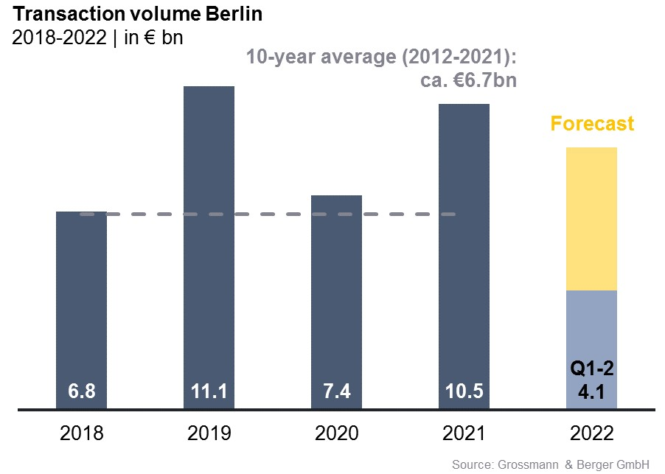

Selected top transactions | investments in Berlin | 1st + 2nd quarters of 2022
Project/property  Street no. | Sub-market | Asset class | Buyer/investor | Vendor | Purchase price*  [approx. €m]
“Sony Center”,  Potsdamer Platz 2 | Potsdamer-/Leipziger Platz | Offices | Norwegian Government Pension Fund Global | Oxford Properties/Madison International Realty | 677
“Sheraton Berlin Grand Hotel”, Lützowufer 15 | Kreuzberg | Hotel | Deutsche Finance International (DFI) | Archer Hotel Capital | 116
“Wriezener Karree”,  Wriezener Karree 15 | Friedrichshain | Commercial building land | Edge Technologies | Aroundtown/TLG | confidential
“Karstadt Müllerstrasse”,  Müllerstrasse 25 | Periphery North | Retail | Signa Development Section | DC Values for insurance company | confidential
“Galerie Lafayette Quartier 207”, Friedrichstrasse 76, 78 | Berlin-Mitte | Offices | Tishman Speyer | Allianz Real Estate | confidential
“Rosy”,  Rosenthaler Straße 44 | Berlin-Mitte | Mixed use | BVK-Values-Immobilienfonds-CBD | Values Real Estate | confidential
*The purchase prices stated are based on publicly available data, where none is available an estimate is made; new transactions or those occurring in the quarter dealt with in this report are highlighted.

The market survey property investment in Berlin 2022/Q2 will soon be available to download from our website.

About Grossmann & Berger
Grossmann & Berger GmbH is one of the leading service providers in the business of selling and letting commercial and residential properties in North Germany. Including its main office in Hamburg, the Company has 22 regional offices. This allows Grossmann & Berger to cover the entire North German market. In May 2021 the company was augmented by E & G Real Estate and
E & G Private Immobilien, so that Grossmann & Berger also operates in the two South German metropolitan areas of Stuttgart and Munich. Drawing on their comprehensive expertise in the real estate business, some 240 employees provide the full range of relevant services. They also benefit from the company’s more than 85 years standing in the industry. Grossmann & Berger belongs to the HASPA Group and is a founding member of the national commercial real estate network German Property Partners (GPP).

Please consult our website for Grossmann & Berger’s data privacy policy. Here you will also be able to access our press kit and the associated Terms of Use. If in future you would prefer not to receive any more information from our press office please e-mail us at presse@grossmann-berger.de quoting as reference "Abmeldung aus Presseverteiler” / “Unsubscribe from press mailing list”.

