Berlin: Investment market, 1st-3rd quarters of 2022
Investors continue to hesitate in view of interest rates

Berlin, 10 October 2022 – By the end of the 3rd quarter a total of €6.3bn had been invested in commercial properties in Berlin; the volume of transactions thus slipped by 2 % year on year (€6.4bn). “The combination of rising interest rates and construction costs, supply chain problems and the prevailing geopolitical tensions is clearly impacting Berlin’s investment market. Despite strong letting figures and the ongoing availability of cash, investors hesitate to conclude transactions,” explains Sandra Ludwig, managing director of Grossmann & Berger, member of German Property Partners (GPP).

Nevertheless, the total traded was well above the ten-year average of €4.8bn. The 3rd-quarter result owes much to six transactions in which properties sold for more than €100m. Between July and September sales of commercial real estate totalled €2.2bn or close to 5 % higher than in the same quarter a year ago (€2.1bn). “Demand for logistics and office real estate in Berlin’s top locations remains high. However, investors hesitate to make a purchase decision due to a shortage of reference transactions,” days Ludwig.

Market details:
- 67 % of the total volume traded comprised property sales of more than €100m each. The 3rd-quarter sale of the “Voltair” office building played a large part in making this price category so predominant. The next two price categories, €51m to €100m and €26m to €50m, played marginal roles only, taking 16 % and 12 % of the market respectively.
- Year on year the market share of portfolio sales climbed to 30 %, an increase of 117 % (14 % in Q3/2021).
- Comprising 71 % of the market, office properties accounted for the lion’s share of commercial real estate traded, an increase of 86 % compared with the same quarter a year before (38 %). Mixed-use properties were the only other asset class to post a two-figure share of the total traded (10 %).
- International buyers were very active on the market, accounting for 70 % of investment in Berlin real estate (Q3 2021: 62 %).
- Professionals’ pension schemes and pension funds were the biggest group of buyers, behind 17% of the total traded. Fund managers and open-ended property funds followed with 16 % and 12 % respectively.
- As in the prior year, developers were the most active vendors, featuring in 17 % of the volume traded, followed by fund managers (16 %) and listed property investment AGs/REITs (13 %).
- Year on year prime yields on office properties (2.9 %) and on commercial buildings (3.05 %) grew by 0.25 percentage points. The prime yield on logistics properties fell by 0.2 percentage points to 3.3 %, but rose by 0.1 percentage points against the previous quarter.
- At 21 % of the total, a higher volume of properties was traded in Berlin-Mitte than in other sub-markets. Here too the strong 3rd-quarter result was attributable to the sale of the “Voltair” office building. Potsdamer/Leipziger Platz and Mitte 1a followed with market shares of 12 % and 10 %.
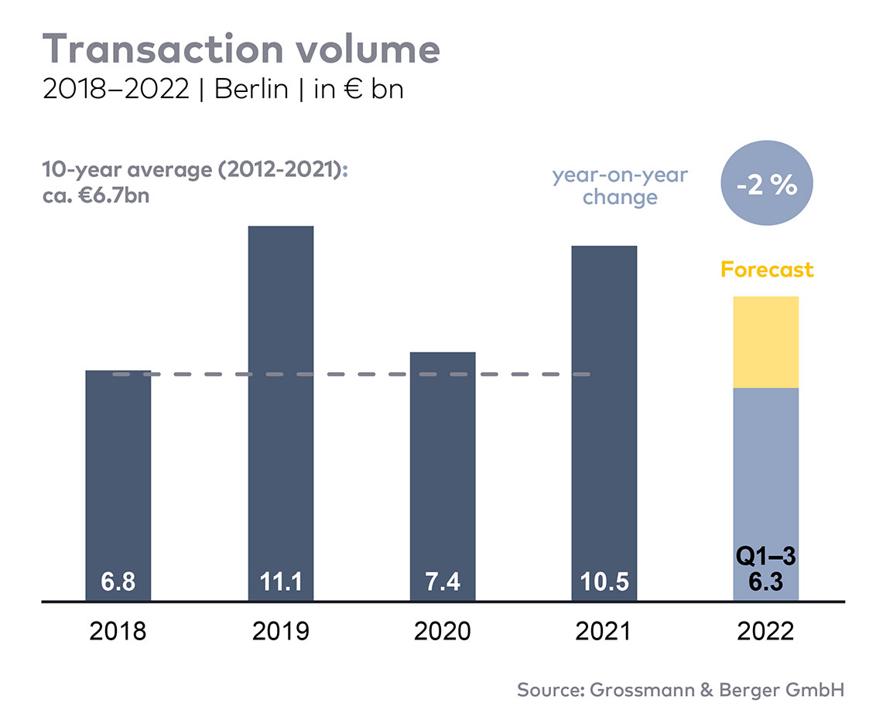
Investment market | Berlin | 2022 | Q 1-3
Transaction volume [€ millions] | 6,300
against prior yr [%] | -2
Proportion of international investors [%] | 70
Prime net yield, office [%] | 2.9
against prior yr [percentage points] | +0.25
Prime net yield, commercial buildings [%] | 3.05
against prior yr [percentage points] | +0.25
Prime net yield, logistics properties [%] | 3.3
against prior yr [percentage points] | -0.2
Strongest asset class | Offices
Strongest asset class [%] | 71

Selected top transactions | investments in Berlin | Q 1-3 2022
Project/property  Street no. | Sub-market | Asset class | Buyer/investor | Vendor | Purchase price*  [approx. €m]
“Sony Center”,  Potsdamer Platz 2 | Potsdamer-/Leipziger Platz | Offices | Norwegian Government Pension Fund Global | Oxford Properties/Madison International Realty | 677
“Voltair”, Voltairestrasse 2a | Berlin-Mitte | Offices | Norges Bank Investment Management and Swiss Life Asset Managers | Gädeke & Sons | 457
“QH Core”, Heidestrasse 5 and “QH Spring”, Heidestrasse 6 | Hauptbahnhof / Europacity | Offices | Vivion | Aggregate Holdings | 456
“Sheraton Berlin Grand Hotel”, Lützowufer 15 | Kreuzberg | Hotel | Deutsche Finance International (DFI) | Archer Hotel Capital | 116
“Wriezener Karree”,  Wriezener Karree 15 | Friedrichshain | Commercial building land | Edge Technologies | Aroundtown/TLG | confidential
*The purchase prices stated are based on publicly available data, where none is available an estimate is made; new transactions or those occurring in the quarter dealt with in this report are highlighted.

The Market survey property investment in Berlin 2022/Q3 will soon be available to download from our website.

About Grossmann & Berger
Grossmann & Berger GmbH is one of the leading service providers in the business of selling and letting commercial and residential properties in North Germany. Including its main office in Hamburg, the Company has 22 regional offices. This allows Grossmann & Berger to cover the entire North German market. In May 2021 the company was augmented by E & G Real Estate and
E & G Private Immobilien, so that Grossmann & Berger also operates in the two South German metropolitan areas of Stuttgart and Munich. Drawing on their comprehensive expertise in the real estate business, some 240 employees provide the full range of relevant services. They also benefit from the company’s more than 85 years standing in the industry. Grossmann & Berger belongs to the HASPA Group and is a founding member of the national commercial real estate network German Property Partners (GPP).

Please consult our website for Grossmann & Berger’s data privacy policy. Here you will also be able to access our press kit and the associated Terms of Use. If in future you would prefer not to receive any more information from our press office please e-mail us at presse@grossmann-berger.de quoting as reference "Abmeldung aus Presseverteiler” / “Unsubscribe from press mailing list”.

