Berlin: Investment market, 1st-4th quarters of 2022
Small-scale transactions instead of the typical large-volume trades
Berlin, 03 January 2023 – Wait-and-see stances and protracted sales negotiations slowed business on the investment market for commercial real estate in Berlin up to and including the 4th quarter. By the end of the year the volume of transactions had reached €7.8bn, which translates into a year on year decline of 26 %. This result is appreciably lower than the five-year average of €8.7bn but well above the ten-year average of €7.1bn.

“Towards the end of the year increased and volatile interest rates characterized the market for commercial property trading in Berlin. Investors still do not have a reliable basis on which to asses the costs of buying a property“, says Sandra Ludwig, managing director of Grossmann & Berger, member of German Property Partners (GPP). Many sales processes were delayed or broken off altogether. Above all in the 2nd half year institutional investors became conspicuously cautious.

Ludwig’s forecast for the coming year is, “In 2023 interest rates and the political situation in Eastern Europe will continue to rattle investors. In the middle of the year we expect to see a partial recovery, if stable interest rates permit more reliable cost calculations.”

Market details:
- Office properties were the most popular class of assets, accounting for 73 % of total demand. Mixed-use properties were the only other asset class to post a two-figure share of the total traded (10 %). Building land took third place, with some 7 % of the market.
- Transactions falling into the price category of €100m or more accounted for a majority of the total traded, as was the case a year ago. However, this category’s 2022 share of 67 % consisted of 24 trades and thus far fewer than in 2021 (34). Trailing some way behind came the next two price categories, €51m to €100m (17 %) and €26m to €50m (11 %).
- Portfolio sales generated about 34 % of the total traded.
- International investors comprised around 60 % of the market. By contrast with the 1st half year (71 %) they have become noticeably more cautious, accounting for 58 % in the 2nd half year.
- Investment managers were the most active group of buyers (16 %) but compared with the previous year their market share declined by some 46 %. This is attributable to caution and uncertainty on the part of their institutional investors. Second place was occupied by professionals’ pension schemes and pension funds (14 %), followed by open-ended property mutual funds (10 %).
- As vendors, investment managers (21 %) replaced listed real estate investment AGs/REITs as the biggest player group in the 4th quarter. Developers took second place, with some 16 % of the market.
- Berlin-Mitte sub-market accounted for the largest share of the transaction volume (23 %), ahead of Tiergarten (14 %) and Potsdamer/Leipziger Platz (10 %).
- Because interest rates were high, prime yields on every type of asset rose appreciably. Yields on office properties (3.00 %) and commercial buildings (3.25 %) rose by 0.30 and 0.45 percentage points respectively. The prime yield on logistics properties rose by 0.10 percentage points year on year to 3.50 %.
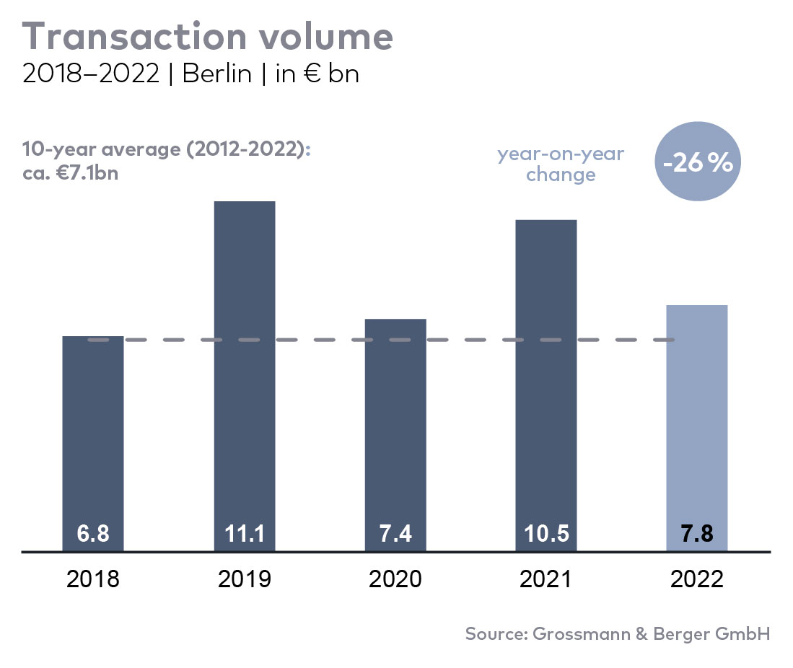
Investment market | Berlin | 2022 | Q1-4
Transaction volume [€ millions] | 7,800
against prior yr [%] | -26
Proportion of international investors [%] | 60
Prime net yield, office [%] | 3.0
against prior yr [percentage points] | +0.3
Prime net yield, commercial buildings [%] | 3.25
against prior yr [percentage points] | +0.45
Prime net yield, logistics properties [%] | 3.5
against prior yr [percentage points] | +0.1
Strongest asset class | Offices
Strongest asset class [%] | 73

Selected top transactions | investments in Berlin | Q1-4 2022
Project/property  Street no. | Sub-market | Asset class | Buyer/investor | Vendor | Purchase price*  [approx. €m]
“Sony Center” Bahn-Tower, Sony European Head Office, Sanofi-Haus, Bürogebäude am Forum, Passarelle | Potsdamer-/Leipziger Platz | Offices | Norwegian Government Pension Fund Global | Oxford Properties/Madison International Realty | 677
“Voltair”, Voltairestrasse 2a | Berlin-Mitte | Offices | Norwegian Government Pension Fund Global / Swiss Life | Gädeke & Sons / ABG | 457
“QH Core” / “QH Spring”, Heidestrasse 6 | Tiergarten | Offices | Vivion Group | Aggregate Holdings | 456
“Urban Tech Republic”, Saatwinkler Damm 74 | Reinickendorf | Offices | Land Berlin Liegenschafts-fonds (real estate fund) | Bundesanstalt für Immobilienaufgaben (Federal real estate) | 261
“Techno Campus”, Siemensdamm 59-63 | Periphery West | Offices | Caleus Capital Partners for GIC | Axa Investment Managers | confidential
*The purchase prices stated are based on publicly available data, where none is available an estimate is made; new transactions or those occurring in the quarter dealt with in this report are highlighted.

The Market survey property investment in Berlin 2022/Q4 will soon be available to download from our website.

About Grossmann & Berger
Grossmann & Berger GmbH is one of the leading service providers in the business of selling and letting commercial and residential properties in North Germany. Including its main office in Hamburg, the Company has 22 regional offices. This allows Grossmann & Berger to cover the entire North German market. In May 2021 the company was augmented by E & G Real Estate and
E & G Private Immobilien, so that Grossmann & Berger also operates in the two South German metropolitan areas of Stuttgart and Munich. Drawing on their comprehensive expertise in the real estate business, some 240 employees provide the full range of relevant services. They also benefit from the company’s more than 85 years standing in the industry. Grossmann & Berger belongs to the HASPA Group and is a founding member of the national commercial real estate network German Property Partners (GPP).

Please consult our website for Grossmann & Berger’s data privacy policy. Here you will also be able to access our press kit and the associated Terms of Use. If in future you would prefer not to receive any more information from our press office please e-mail us at presse@grossmann-berger.de quoting as reference "Abmeldung aus Presseverteiler” / “Unsubscribe from press mailing list”.

