Hamburg: Investment Market, 1st Quarter of 2023
Start to the year characterized by slow sales activity

Hamburg, 03 April 2023 - It came as no surprise that the market for investments in commercial properties in Hamburg was very quiet in the 1st quarter. In the first three months the volume of transactions totalled a mere €170m. Compared with the 1st quarter of the prior year (€1.9bn) – exceptionally strong due to the takeover of alstria by Brookfield Properties – the overall result has contracted by 91 %. Discounting said outlier transaction, the shortfall decreases to 61 %. “Across the nation there is an ongoing process of reassessing prices in the light of the new business environment. However, it would appear that this process is approaching completion so that in the near future investors will be able to plan with greater confidence. Both the positive macro-economic environment and stability on the market for commercial lets offer good investment prospects for the future. I am therefore confident that we will be seeing more transactions in the second half of the year,” says Frank-D. Albers, managing director of Grossmann & Berger, a member of German Property Partners.

Market details:
Note: Since the following figures are based on only 10 transactions, their information value is limited.
- Institutional investors were particularly reluctant to commit funds due to the lack of certainty about the market’s future. Accordingly, no large-volume transactions were noted. The biggest transaction was Deutsche Euroshop’s purchase of additional shares in the Phoenix Center mall in Harburg district.
- With some 42 % of the total market, office real estate was the most-traded class of asset, followed by retail properties at 28 %.
- Accounting for 34 % of the volume traded, developers formed the most active group of buyers. The most active vendors on the market were real estate companies (18 %).
- Due to the ongoing lack of certainty on the market, international investors were holding back. Their share of the transaction volume was 11 %.
- Year on year the prime yields have leapt up: on commercial properties yields grew by 0.9 percentage points to 3.6 %, on offices by 0.9 percentage points to 3.5 % and on industrial and logistics real estate by 0.9 percentage points to 4.2 %. These yields are estimated on the basis of only a small number of real reference cases.

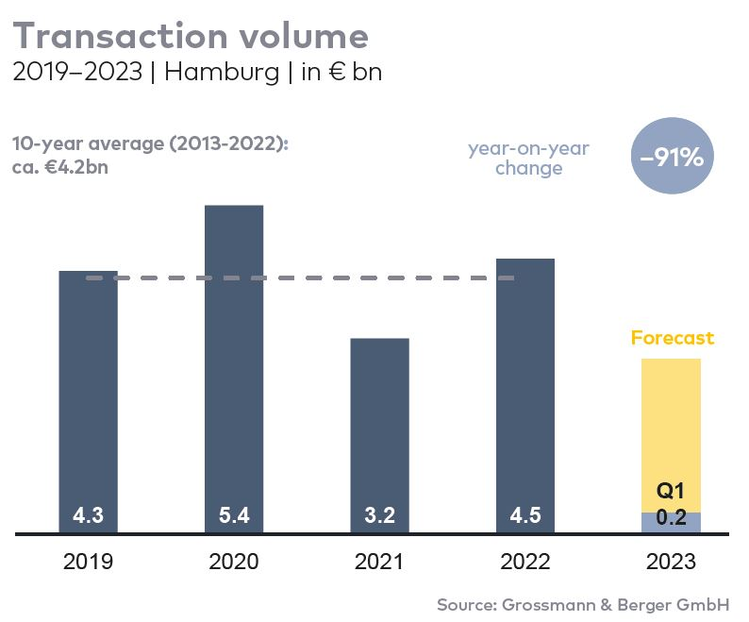
Investment market | Hamburg | 2023 | Q1
Transaction volume [€ millions] | 170
against prior yr [%] | -91
Proportion of international investors [%] | 11
Prime net yield, office [%] | 3.50
against prior yr [percentage points] | +0.90
Prime net yield, commercial buildings [%] | 3.60
against prior yr [percentage points] | +0.90
Prime net yield, logistics properties [%] | 4.20
against prior yr [percentage points] | +0.90
Strongest asset class | Offices
Strongest asset class [%] | 42

Selected top transactions | investments in Hamburg | 1st quarter of 2023
Project/property  Street no. | Sub-market | Asset class | Buyer/investor | Vendor | Purchase price*  [approx. €m]
DES Phoenix Center (25%),  Hannoversche Strasse 86 | Harburg | Retail | Deutsche EuroShop AG | Otto Group | 29.4
Select Hotel Hamburg Nord,  Oldesloer Straße 166 | Hamburg West | Hotel | City of Hamburg (Fördern & Wohnen) | confidential | confidential
Multi-storey car park,  Obenhauptstrasse 15 | Airport | Other properties | Catella Real Estate AG / Orange Investment Managers | Adler Gruppe | confidential
* The purchase prices stated are based on publicly available data, where none is available an estimate is used instead.

The market survey property investment in Hamburg 2023/Q1 will soon be available to download from our website.

About Grossmann & Berger
Grossmann & Berger GmbH is one of the leading service providers in the business of selling and letting commercial and residential properties in North Germany. With headquarters in Hamburg and branches in Berlin, Stuttgart and Munich, the Group comprising Grossmann & Berger and E & G Immobilien has offices in 22 locations across Germany. Drawing on their comprehensive expertise in the real estate business, some 250 employees provide the full range of property services. They also tap into the Company’s fund of business knowledge accumulated over more than 90 years. Grossmann & Berger belongs to the HASPA-Group and is a founding member of the national commercial real estate network German Property Partners (GPP).

Please consult our website for Grossmann & Berger’s data privacy policy. Here you will also be able to access our press kit and the associated Terms of Use. If in future you would prefer not to receive any more information from our press office please e-mail us at presse@grossmann-berger.de quoting as reference "Abmeldung aus Presseverteiler” / “Unsubscribe from press mailing list”.

