Hamburg: Investment Market, 1st - 2nd quarters of 2022
Downturn in transactions due to higher cost of borrowing

Hamburg, 30 June 2022 – Higher borrowing costs are making themselves felt on the Hamburg market for investment in commercial real estate. Admittedly, the volume of transactions concluded in the 1st half of 2022 totalled some €2.3bn, thus rising year on year by 111 %. What seems to be a very good result is, however, largely due to the take-over of the huge alstria office portfolio, which Brookfield Properties acquired in the 1st quarter. Discounting this outlier transaction, at the end of the 2nd quarter the volume of transactions totalled some €840m, or 23 % below the rather modest figure seen in the previous year, and well below the ten-year average of €1.51bn. By the close of the 2nd quarter Grossmann & Berger, a member of German Property Partners (GPP), had registered a mere 34 transactions. Managing director Sandra Ludwig says, “Although investors are less willing to commit due to higher and extremely volatile interest rates, many would-be sellers are not yet prepared to accept that, consequently, they will have to reduce the asking price. This means that transactions, especially big-ticket trades, are placed on hold for the time being.” Investors with the means to buy with very little leverage are at an advantage. Despite this, Ludwig looks ahead to the 2nd half year with optimism; “There is capital on the market that needs to be invested. For that reason I expect to see trading revive by the fourth quarter at the latest.”

Market details:
- Office real estate was the predominant class of asset in the first two quarters of 2022, accounting for 79 % of total trading. Second and third places went to retail properties (10 %) and commercial building land (4 %).
- Apart from the alstria portfolio, only two properties traded for more than €100m, namely the “Klöpperhaus” at Mönckebergstrasse 3 and the “EDGE ElbSide.”
- Due to the alstria trade, portfolio sales accounted for 69 % of the total. Ignoring alstria, the proportion of portfolios falls to a mere 7 % of the trading volume.
- Accounting for some 69 % of the volume traded, fund managers were the biggest single group of buyers. Their strong presence on the market is attributable to the 1st quarter outlier transaction mentioned previously. If this trade is factored out, private equity and opportunity funds formed the biggest group of buyers, with 29 % of the market.
- The biggest group of sellers consisted of listed real estate investment AGs/REITs; their 69 % share of the market is likewise a result of the alstria trade. Excluding this outlier trade, insurance companies, open-ended property mutual funds and developers were the major sellers of real estate.
- At 79 %, the share of international buyers was exceptionally high. Without the alstria transaction, this figure drops to 36 %.
- Year on year the prime yields on commercial buildings (2.7 %) and offices (2.6%) were unchanged, whereas on industrial and logistics properties the figure fell by 0.5 percentage points to 3.3 %. During the course of the year yields are expected to rise due to higher interest rates.

Investment market | Hamburg | 2022 | Q1 -2
Transaction volume [€ millions] | 2,300
against prior yr [%] | +111
Proportion of international investors [%] | 79
Prime net yield, office [%] | 2.60
against prior yr [percentage points] | ±0.00
Prime net yield, commercial buildings [%] | 2.70
against prior yr [percentage points] | ±0.00
Prime net yield, logistics properties [%] | 3.30
against prior yr [percentage points] | -0.50
Strongest asset class | Offices
Strongest asset class [%] | 79
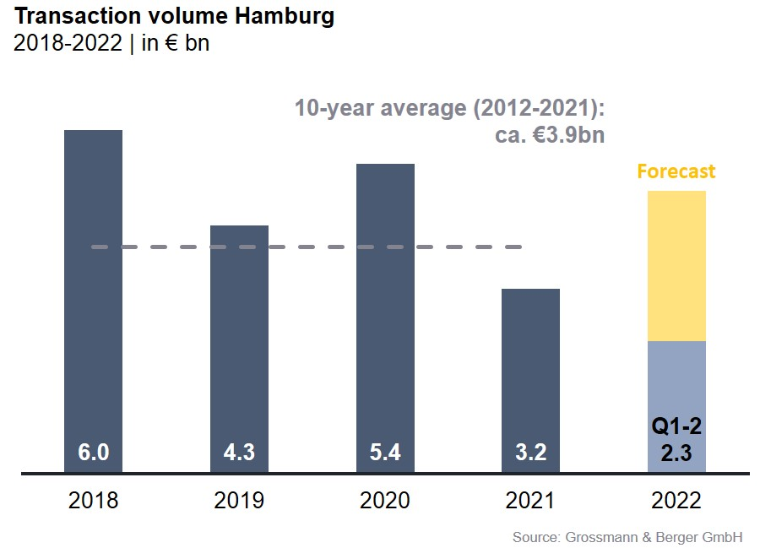

Selected top transactions | investments in Hamburg | 1st + 2nd quarters of 2022
Project/property  Street no. | Sub-market | Asset class | Buyer/investor | Vendor | Purchase price*  [approx. €m]
“alstria office” portfolio | Hamburg | Offices | Brookfield Properties | alstria office REIT | 1,500
“Klöpperhaus”  (formerly Galeria Kaufhof) | City | Retail | Tishman Speyer | Württembergische Lebensversicherung (insurance co.) | > 160
“EDGE Elbside” (50 %) | HafenCity | Offices | Ampega Asset Management | HanseMerkur Grundvermögen | > 100
Building land Seehafenstrasse | Hamburg South | Commercial building land | Project developers | Corporate | 70
“Peute Dock” (section of site),  Oberwerder Damm 11-21 | Hamburg East | Industry / logistics | DIC Asset | Family Value Management | 45
* The purchase prices stated are based on publicly available data, where none is available an estimate is used instead Transactions occurring in the quarter covered by this report are highlighted.

The market survey property investment in Hamburg 2022/Q2 will soon be available to download from our website.

About Grossmann & Berger
Grossmann & Berger GmbH is one of the leading service providers in the business of selling and letting commercial and residential properties in North Germany. Including its main office in Hamburg, the Company has 22 regional offices. This allows Grossmann & Berger to cover the entire North German market. In May 2021 the company was augmented by E & G Real Estate and
E & G Private Immobilien, so that Grossmann & Berger also operates in the two South German metropolitan areas of Stuttgart and Munich. Drawing on their comprehensive expertise in the real estate business, some 240 employees provide the full range of relevant services. They also benefit from the company’s more than 85 years standing in the industry. Grossmann & Berger belongs to the HASPA Group and is a founding member of the national commercial real estate network German Property Partners (GPP).

Please consult our website for Grossmann & Berger’s data privacy policy. Here you will also be able to access our press kit and the associated Terms of Use. If in future you would prefer not to receive any more information from our press office please e-mail us at presse@grossmann-berger.de quoting as reference "Abmeldung aus Presseverteiler” / “Unsubscribe from press mailing list”.

