Hamburg: Investment Market, 1st - 3rd quarters of 2022
Share purchases and take-overs boost volume of transactions

Hamburg, 30 September 2022 — The volume of transactions completed on the market for commercial real estate in Hamburg stood at some €3.9bn by the end of the 3rd quarter. This figure was well above that of the prior year (€2.1bn) and was in fact the second-highest total ever recorded at the end of a third quarter, topped only by the record €4bn noted in 2018. Nearly half of the transaction volume was completed in the 3rd quarter. However, the high figure owed much to some outlier trades. “The figures seem to indicate brisk trading, but about half of this year’s overall volume to date results from major take-over deals and the acquisition of shareholdings in development projects,” reports Sandra Ludwig, managing director of Grossmann & Berger, a member of German Property Partners (GPP). As Grossmann & Berger has observed, trades of this kind included the takeover of the huge alstria portfolio (Q1) and the purchase of shareholdings in the “Elbtower” (Q3) and “EDGE ElbSide” (Q2). If these outlier trades are factored out, the volume of transactions falls to a mere €1.9bn. Ludwig expects the year to close on a more subdued note. “The increased costs of borrowing coupled with persistently high asking prices continue to weigh on the market. Interest rates have now reached a level last seen ten years ago. Therefore there is ongoing pressure on sellers to reduce prices.” Thanks to the outlier trades, the volume of transactions has already surpassed the total for the full year in 2021 (€3.2bn).

Market details:
- Once again, office properties were the most sought-after asset class, accounting for 80 % of total trading. Trailing a long way behind, retail properties (9 %) and logistics real estate (7 %) were in second and third place. Even without the alstria portfolio, 68 % of trades related to office buildings.
- Portfolio sales generated 43 % of the total traded. Without the alstria transaction, their share would have been only 8 %.
- Fund managers were the biggest group of investors, responsible for some 42 % of the volume – likewise a result of the alstria portfolio. Discounting this trade, specialist funds were the biggest group of investors (29 %) followed by open-ended property investment funds (23 %).
- Looking at the Vendors, property investment AGs/REITs were predominant with a market share of some 44 %. Factoring out the alstria outlier trade, developers (35 %) and open-ended property investment funds (27 %) were the biggest groups of vendors.
- International investors accounted for 56 % of the volume traded. Without the alstria transaction, their share would have been 29 %.
- The prime yields on office properties (2.9 %) and commercial buildings (3.0 %) inched up by 0.3 percentage points year on year. Yields on industrial and logistics real estate remained unchanged year on year but were 0.2 percentage points higher than in the previous quarter. Yields are expected to rise

further by the end of the year due to rising interest rates.
Investment market | Hamburg | 2022 | Q 1-3
Transaction volume [€ millions] | 3,900
against prior yr [%] | +86
Proportion of international investors [%] | 56
Prime net yield, office [%] | 2.90
against prior yr [percentage points] | +0.30
Prime net yield, commercial buildings [%] | 3.00
against prior yr [percentage points] | +0.30
Prime net yield, logistics properties [%] | 3.50
against prior yr [percentage points] | ±0.00
Strongest asset class | Offices
Strongest asset class [%] | 80
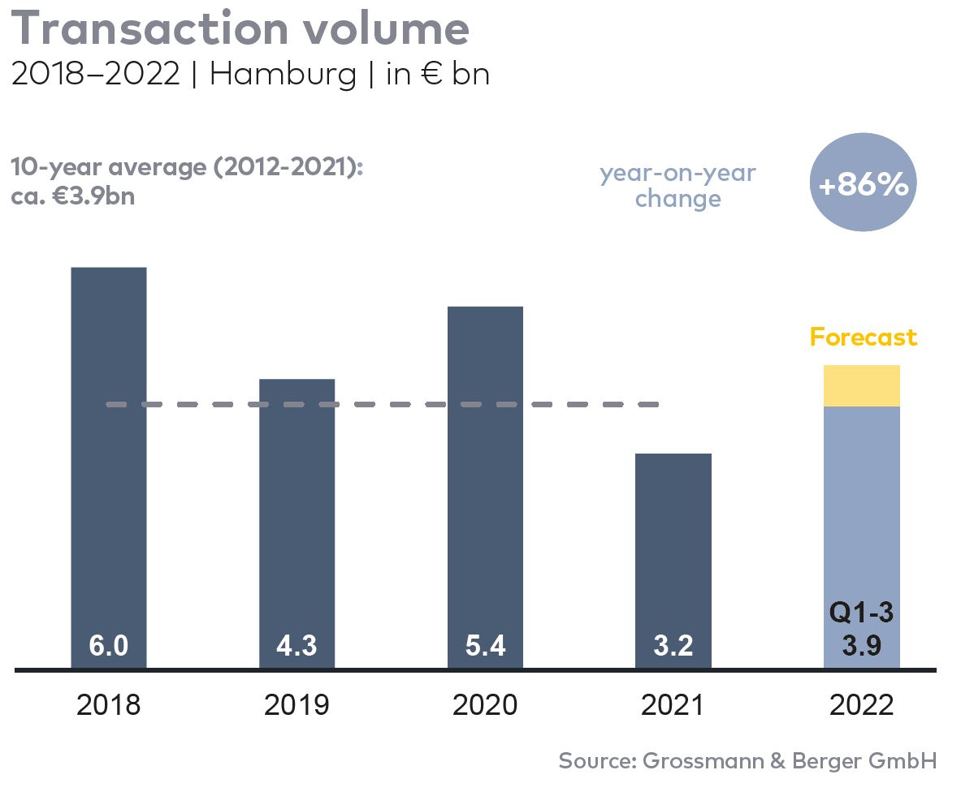

Selected top transactions | investments in Hamburg | 1st-3rd quarters of 2022
Project/property  Street no. | Sub-market | Asset class | Buyer/investor | Vendor | Purchase price*  [approx. €m]
“alstria office” portfolio | Hamburg | Offices | Brookfield Properties | alstria office REIT AG | 1,500
“Altes Fernmeldeamt” | Alster West | Offices | Values Real Estate | Peakside Capital | 400
“Elbtower” (25 %) | HafenCity | Offices | Commerz Real | Signa Holding | confidential
“Klöpperhaus”  (formerly Galeria Kaufhof) | City | Retail | Tishman Speyer | Württembergische Lebensversicherung (insurance co.) | ±160
“ConneXion Office” | City | Offices | Erste Immobilien KAG | Becken Development | ±150
“EDGE Elbside” (50 %) | HafenCity | Offices | Ampega Asset Management | HanseMerkur Grundvermögen | ±100
* The purchase prices stated are based on publicly available data, where none is available an estimate is used instead. Transactions occurring in the quarter covered by this report are highlighted.

The market survey property investment in Hamburg 2022/Q3 will soon be available to download from our website.

About Grossmann & Berger
Grossmann & Berger GmbH is one of the leading service providers in the business of selling and letting commercial and residential properties in North Germany. Including its main office in Hamburg, the Company has 22 regional offices. This allows Grossmann & Berger to cover the entire North German market. In May 2021 the company was augmented by E & G Real Estate and
E & G Private Immobilien, so that Grossmann & Berger also operates in the two South German metropolitan areas of Stuttgart and Munich. Drawing on their comprehensive expertise in the real estate business, some 240 employees provide the full range of relevant services. They also benefit from the company’s more than 85 years standing in the industry. Grossmann & Berger belongs to the HASPA Group and is a founding member of the national commercial real estate network German Property Partners (GPP).

Please consult our website for Grossmann & Berger’s data privacy policy. Here you will also be able to access our press kit and the associated Terms of Use. If in future you would prefer not to receive any more information from our press office please e-mail us at presse@grossmann-berger.de quoting as reference "Abmeldung aus Presseverteiler” / “Unsubscribe from press mailing list”.

