Hamburg: Investment market, 1st-4th quarters of 2022
Few large-volume transactions at the end of the year

Hamburg, 02 January 2023 — The volume of transactions completed on the market for commercial real estate in Hamburg stood at some €4.5bn by the end of the 4th quarter. This represents a year on year increase of 41 %. The overall volume of transactions was thus higher than the 10-year average of some €4.2bn but this apparently record result was the result of certain outlier trades. Apart from the take-over of the alstria office REIT AG by Brookfield Properties (1st quarter) the year 2022 featured additional take-overs and sales of shareholdings as opposed to classic asset trades. Discounting outlier transactions, the volume traded totalled only €2.5bn or 22 % below the figure for 2021 and some 41 % below the ten-year average.

Despite the uncertain market environment, more transactions were noted in the 2nd half year than in the first. Above all in the 4th quarter these were, however, trades priced at less than €50m. Large-volume individual transactions were rare. Taking the entire year into consideration, 23 % fewer transactions were recorded than in 2021. One notable aspect is that inner-city properties dominated trading in the last quarter. Nearly 40 % of the transactions in the 4th quarter involved inner city real estate. “Due to increased interest rates, investors with deep pockets were able to establish themselves as buyers in the 2nd half year, investing in centrally located core real estate with stable value preservation”, comments Sandra Ludwig, managing director of Grossmann & Berger, member of German Property Partners (GPP).

Changes in the base rate and the political situation in Eastern Europe still pose risks and uncertainties for investors and continue to promote caution among institutional investors. Ludwig expects trading to be sluggish at the beginning of 2023. “We expect to see brisker business in the 2nd half of the year because by then, in response to the increased rates of interest, prices will have settled at new levels and investors will be able to make more reliable calculations.”

Market details:
- Accounting for 78 % of the volume, office properties were the most traded class of asset. Their above average share of the market is attributable to the alstria-Brookfield outlier trade. Second and third places went to retail properties (10 %) and logistics and industrial real estate (6 %).
- Due to the alstria take-over, portfolio sales generated some 37 % of the total volume traded.
- Accounting for 37 % of the volume traded, fund managers were the most active group of buyers. They were followed by specialist funds with 16 % of the market and open-ended property mutual funds with some 14 %.
- Due to the alstria take-over, listed real estate investment AGs/REITS were the strongest group of vendors, accounting for some 38 % of the market. They were followed by developers (21 %) and, in third place, open-ended property mutual funds (17 %).
- International investors comprised around 50 % of the market. If the alstria-Brookfield trade is factored out, their share drops to 25 %.
- Because interest rates were high, prime yields on every type of asset rose too. Year on year growth of 0.5 percentage points was noted for office properties (3.10 %) and commercial buildings (3.20 %). Prime yields on industrial and logistics properties rose by 0.30 percentage points to 3.80 %.
Investment market | Hamburg | 2022 | Q1-4
Transaction volume [€ millions] | 4,500
against prior yr [%] | +41
Proportion of international investors [%] | 50
Prime net yield, office [%] | 3.10
against prior yr [percentage points] | +0.50
Prime net yield, commercial buildings [%] | 3.20
against prior yr [percentage points] | +0.50
Prime net yield, logistics properties [%] | 3.80
against prior yr [percentage points] | +0.30
Strongest asset class | Offices
Strongest asset class [%] | 78
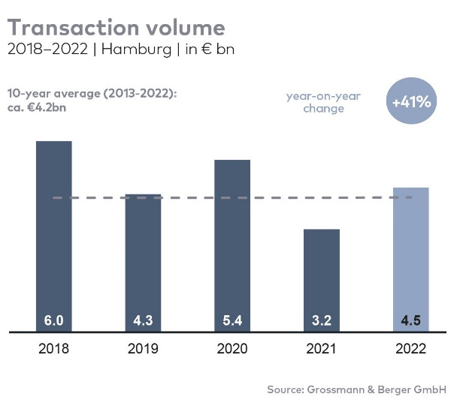

Selected top transactions | investments in Hamburg | Q1-4 2022
Project/property  Street no. | Sub-market | Asset class | Buyer/investor | Vendor | Purchase price*  [approx. €m]
“alstria office” portfolio | Hamburg | Offices | Brookfield Properties | alstria office REIT AG | 1,500
“Altes Fernmeldeamt” | Alster West | Offices | Values Real Estate | Peakside Capital | 400
“ConneXion Office” | City | Offices | Erste Immobilien KAG | Becken Development | ±150
“Klöpperhaus”  (formerly Galeria Kaufhof) | City | Retail | Tishman Speyer | Württembergische Lebensversicherung (insurance co.) | ±160
“Georgstor”, | St. Georg | Offices | Hines Immobilien GmbH | REAL I.S. AG | 115
“EDGE Elbside” (50 %) | HafenCity | Offices | Ampega Asset Management | HanseMerkur Grundvermögen | ±100
“Elbtower” (25 %) | HafenCity | Offices | Commerz Real | Signa Holding | confidential
“Medical Science Center” | Hamburg East | Offices | HanseMerkur Grundvermögen | Aug. Prien Immobilien | confidential
* The purchase prices stated are based on publicly available data, where none is available an estimate is used instead. Transactions occurring in the quarter covered by this report are highlighted.

The Market survey property investment in Hamburg 2022/Q4 will soon be available to download from our website.

About Grossmann & Berger
Grossmann & Berger GmbH is one of the leading service providers in the business of selling and letting commercial and residential properties in North Germany. Including its main office in Hamburg, the Company has 22 regional offices. This allows Grossmann & Berger to cover the entire North German market. In May 2021 the company was augmented by E & G Real Estate and
E & G Private Immobilien, so that Grossmann & Berger also operates in the two South German metropolitan areas of Stuttgart and Munich. Drawing on their comprehensive expertise in the real estate business, some 240 employees provide the full range of relevant services. They also benefit from the company’s more than 85 years standing in the industry. Grossmann & Berger belongs to the HASPA Group and is a founding member of the national commercial real estate network German Property Partners (GPP).

Please consult our website for Grossmann & Berger’s data privacy policy. Here you will also be able to access our press kit and the associated Terms of Use. If in future you would prefer not to receive any more information from our press office please e-mail us at presse@grossmann-berger.de quoting as reference "Abmeldung aus Presseverteiler” / “Unsubscribe from press mailing list”.

