Hamburg: New-build apartments/condominiums 1st half of 2022
Longer lead times due to changed market environment

Hamburg, 25 August 2022 — Since the beginning of the year the business of selling new-build apartments has changed noticeably. “The strong rise in mortgage rates and high inflation have already combined to reduce demand somewhat. Some customers find the current situation unsettling and are rethinking their plans to buy,” says Frank Stolz, managing director of Grossmann & Berger in his summary of the market. Potential buyers are increasingly seeking advice, especially on issues such as financing the purchase and the benefits of a new-build property in terms of energy efficiency. Therefore properties will take longer to sell in the months ahead.”

Prices rising more slowly in the 1st half of 2022
Stolz reports that, “because the situation has changed, we are no longer registering the enormous surges in prices seen in recent years.” Research by Grossmann & Berger reveals that the price of a new-build apartment in Hamburg is holding steady. Available figures for the 1st half of 2022 show an average asking price* of €8,430 per square meter in development starts within Hamburg city limits. This rate is a mere 0.6 % lower than the price for the full year 2021. In the top 23 residential districts**, i.e. the 23 most sought-after parts of Hamburg, purchase prices were actually 7.2 % higher at €11,100/m².

Considerably more construction starts
Grossmann & Berger noted an increased supply of properties on the market in the 1st half of 2022. Year on year the number of properties coming onto the market grew by 23 developments and 252 residential units. “Some of the developments which had been delayed for a long time by the pandemic went on sale at the beginning of the year,” remarks Stolz. Between January and June Grossmann & Berger noted the start of 49 development projects with 691 residential units. In Rothenburgsort 210 units went on sale, followed by 63 in Barmbek-South and 54 in Horn. The average new-build apartment in Hamburg was 86 m² in size and sold for €728,100. In the top 23 residential districts the price was €854,700 and thus some 17 % more than the average in Hamburg but for 11 % less living space (77 m²). Grossmann & Berger calculated that the highest average square-metre price in the 1st half of 2022 was €13,500 for units in a small development in Ottensen district.

Forecast: Prices are stabilizing
“Overall, we expect to see purchase prices stabilize in the next few months,” predicts Stolz. The G&B Price Trend*** indicates that in 2023 the average asking price for a standard new-build apartment/condominium will settle at its current high level: an average of €8,500/m² within Hamburg city limits and €11.000/m² in the top 23.

The detailed G&B Price Trend 2023, new-build apartments in Hamburg is available for you to download from our website .

* Average asking price:
Figure calculated in reference to all new-build apartment developments included in the survey whose construction start falls within a defined period
** Grossmann & Berger counts the following 23 parts of the city with the greatest new-build demand as the top 23 residential districts. Alsterdorf, Altona-Altstadt, Altona North, Bahrenfeld, Barmbek North, Barmbek South, Eilbek, Eimsbüttel, Eppendorf, HafenCity, Harvestehude, Hoheluft East, Hoheluft West, Hohenfelde, Lokstedt, Othmarschen, Ottensen, Rotherbaum, St. Georg, St. Pauli, Sternschanze, Uhlenhorst, Winterhude
***G&B Price Trend:
Estimate of the prices buyers are prepared to pay for a standard new-build apartment, without reference to location or special features of the project: first occupancy in a new-build, 3 rooms, around 80 m² living space, 1st floor, modern fit-out, elevator, without built-in kitchen or parking space
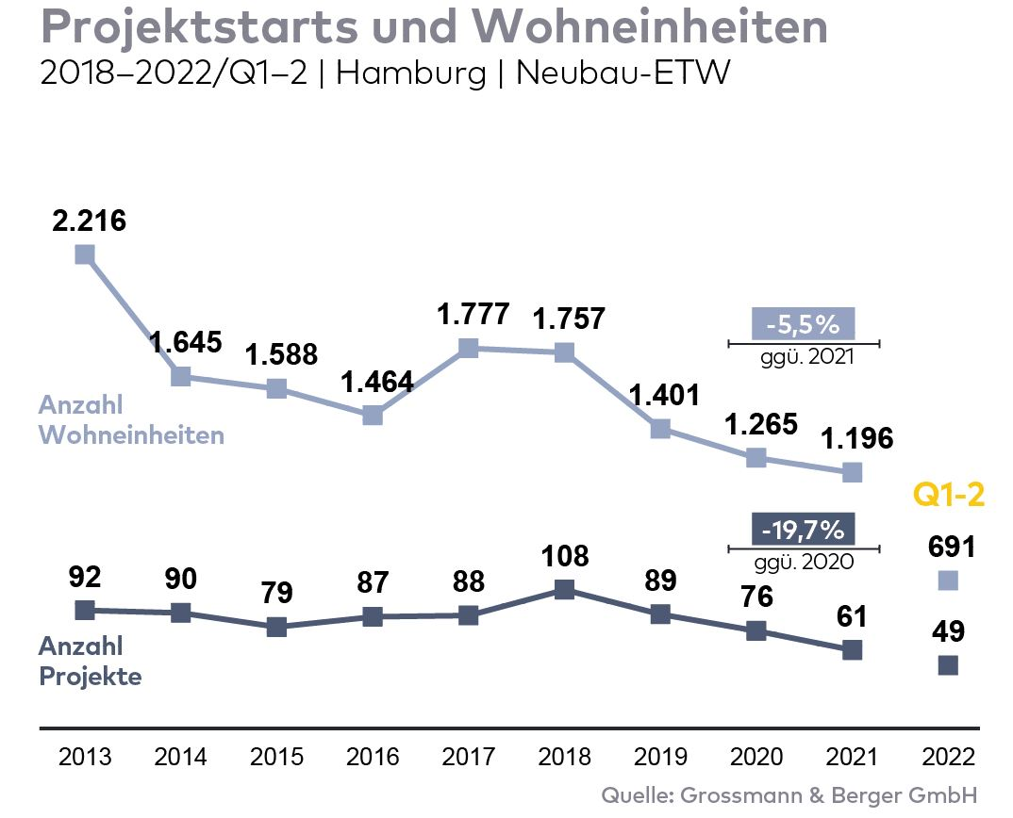
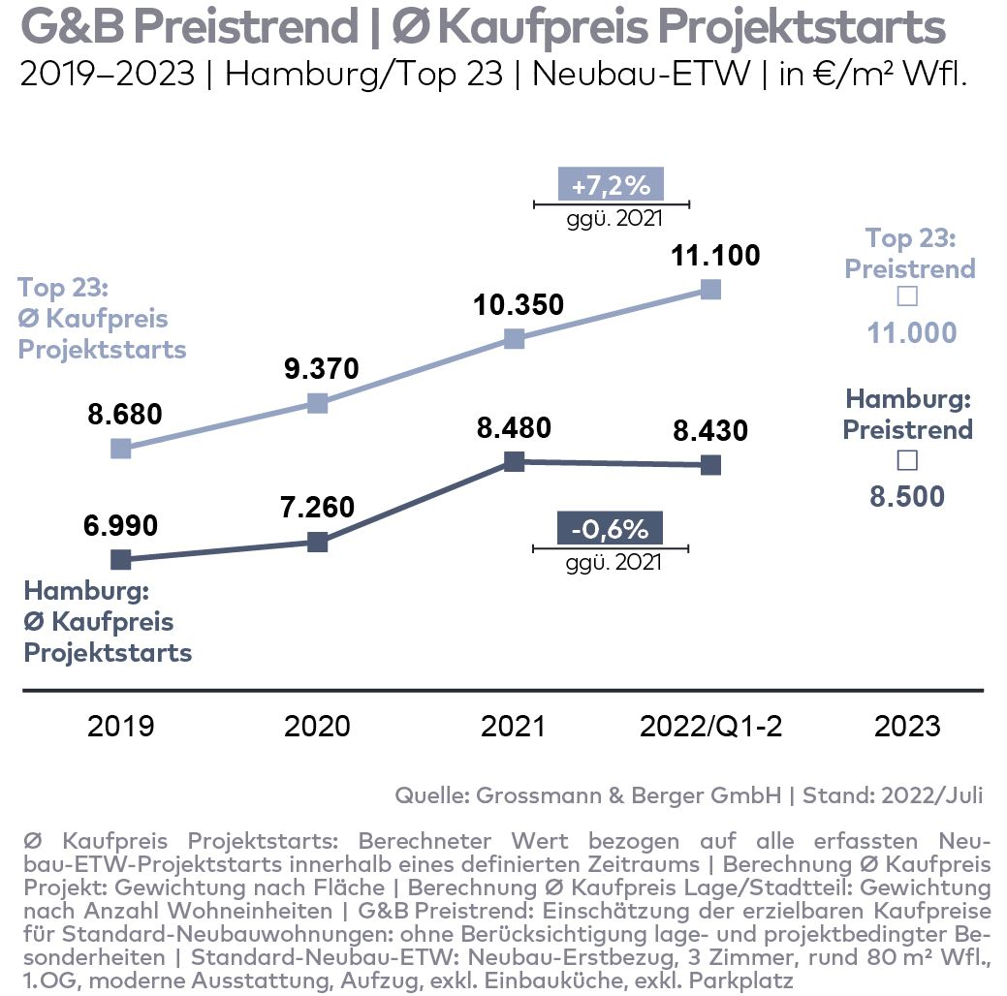
Photo:
Recently Grossmann & Berger commenced the process of selling the 16 apartments/condominiums in the new “Winterhuder Marktplatz 10” development.
Source of visualization: Hasselluhn Kolthoff Link GbR
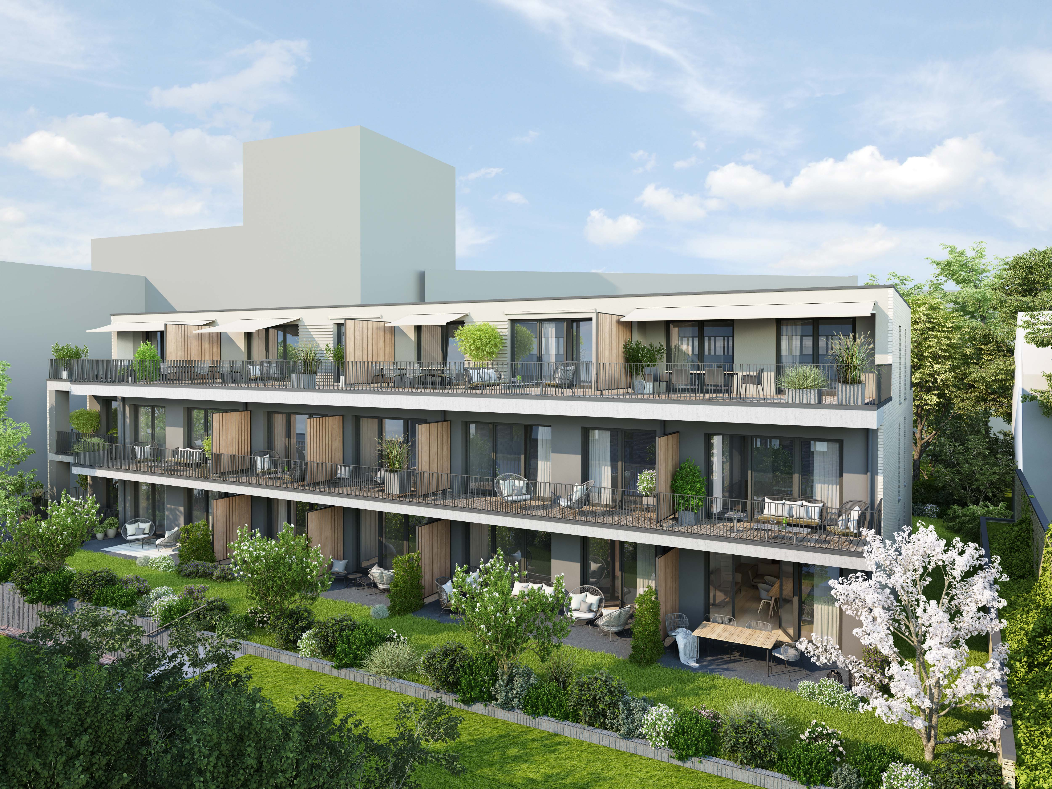

About Grossmann & Berger
Grossmann & Berger GmbH is one of the leading service providers in the business of selling and letting commercial and residential properties in North Germany. Including its main office in Hamburg, the Company has 22 regional offices. This allows Grossmann & Berger to cover the entire North German market. In May 2021 the company was augmented by E & G Real Estate and
E & G Private Immobilien, so that Grossmann & Berger also operates in the two South German metropolitan areas of Stuttgart and Munich. Drawing on their comprehensive expertise in the real estate business, some 240 employees provide the full range of relevant services. They also benefit from the company’s more than 85 years standing in the industry. Grossmann & Berger belongs to the HASPA Group and is a founding member of the national commercial real estate network German Property Partners (GPP).

Please consult our website for Grossmann & Berger’sdata privacy policy Here you will also be able to access our press kit and the associated Terms of Use. If in future you would prefer not to receive any more information from our press office please e-mail us at presse@grossmann-berger.de quoting as reference "Abmeldung aus Presseverteiler” / “Unsubscribe from press mailing list”.

