Hamburg: New-build apartments 2022/2023
No significant price falls expected

Hamburg, 22 February 2023 – According to analyses by Grossmann & Berger, the average asking price* for new-build apartments in Hamburg in 2022 was slightly above the previous year’s level. Prices are expected to become stable in the course of 2023. This is the message from the market report for new-build apartments in Hamburg, published by Grossmann & Berger today. “We are not expecting any significant price falls in the new-build segment in 2023. The construction projects involve long development times that do not permit quick reactions to changes in market activity,” says Frank Stolz, head of new-builds at Grossmann & Berger. “The decline in demand brought about by the increasing cost of financing the purchase is currently making a wide selection of residential units in high-quality new-build developments available to buyers with a strong capital base. This market phase is a favourable time for acquiring a new-build apartment.”

In 2022, the challenging overall conditions caused some construction projects to be placed “on hold”, or not started at all. We must therefore expect a reduced offer of new property in and around Hamburg. Concerning demand, Stolz gives the following prediction: “We assume that interest rates will not fall to their former low level in the medium term. If the development of the economy makes planning easier in the course of the year, and a calculable interest rate below 4 % continues, we are reckoning with a “habituation effect” and a recovery of demand in the second half of the year.”

Price surges for construction start in the top 23 residential districts
The figures for all construction starts analysed in 2022 within Hamburg’s city limits revealed an average asking price* of 8.640 €/m². This corresponds to a slight rise of just under 2 % compared to the previous year. The highest purchase prices for new-build apartments were recorded in the submarket Harvestehude, with an average of 18.420 € per square meter of living space. Based on the developments started in 2022, the average new-build apartment in Hamburg was around 84 m² in size and sold for 725,760 €. In the top 23 residential districts**, classified by Grossmann & Berger as the 23 most sought-after parts of Hamburg, the average purchase price rose again appreciably, by about 6 % year on year, to 10.970 € per square meter of living space.

More construction starts, fewer residential units
For the year 2022 as a whole, Grossmann & Berger registered the start of 85 new developments in Hamburg – a marked increase of nearly 47 % compared to 2021 (61). The number of construction starts recorded therefore almost reached the level of the pre-Covid year 2019 (86). 24 of these developments were in the top 23 residential districts**. However, the number of residential units on offer continued to decline compared to the year before. Here, a fall of around 3 % to 1,210 apartments was noted.

Numerous construction starts in Hamburg’s western environs and Norderstedt
Around Hamburg, the geographic focus of the development activities recorded by Grossmann & Berger lay to the west of the city and in Norderstedt, with ten construction starts each. In the western environs overall, more than 260 residential units were started; in Norderstedt, the figure was just under 200. The average asking prices for the developments recorded in Hamburg’s environs, including semi-detached properties, covered a wide range according to the location and the degree of accessibility from the urban area of the city. The cheapest was a town-house development in Alveslohe, near Henstedt-Ulzburg, with an average of 3.970 €/m². The highest average asking price, namely 8.590 €/m², was calculated for a new construction project in Wedel.

Forecast: prices will stabilize during the year
“In 2023 we are expecting purchase prices to stabilize on the current level – despite inflation and higher construction costs”, says Stolz. “We are only reckoning with price reductions in isolated cases.” According to the G&B Price Trend*** for new-build apartment developments, the average purchase price for standard new-build apartments in 2023 will be 8.500 €/m². For the top 23 residential districts**,Grossmann & Berger forecasts an average of 11.000 €/m².

The detailed G&B Market survey for new-build apartments in Hamburg, 2022/2023 is available as a download from our website.

* Average asking price: Figure calculated in reference to all new-build apartment developments included in the survey whose construction start falls within a defined period
** Grossmann & Berger counts the following 23 parts of the city with the greatest new-build demand as the top 23 residential districts: Alsterdorf, Altona-Altstadt, Altona North, Bahrenfeld, Barmbek North, Barmbek South, Eilbek, Eimsbüttel, Eppendorf, HafenCity, Harvestehude, Hoheluft East, Hoheluft West, Hohenfelde, Lokstedt, Othmarschen, Ottensen, Rotherbaum, St. Georg, St. Pauli, Sternschanze, Uhlenhorst, Winterhude.
*** G&B Price Trend: Estimate of the prices buyers are prepared to pay for a standard new-build apartment, without reference to location or special features of the project: first occupancy in a new-build, 3 rooms, around 80 m² living space, 1st floor, modern fit-out, elevator, without built-in kitchen or parking space.

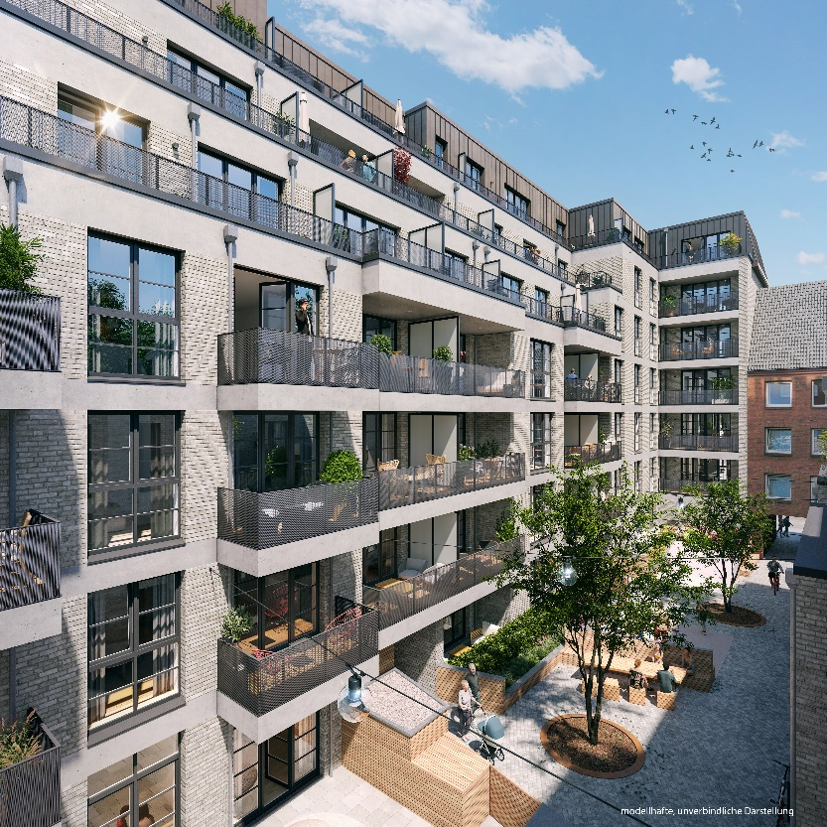 | Caption:  Hamburg’s Schanzenviertel district is the location of the “Schanzenkind” development: 25 new-build apartments with a modern fit-out, and four town houses. |  Non-binding, model presentation.  Source: dreidesign GmbH

About Grossmann & Berger
Grossmann & Berger GmbH is one of the leading service providers in the business of selling and letting commercial and residential properties in North Germany. Including its main office in Hamburg, the Company has 22 regional offices. This allows Grossmann & Berger to cover the entire North German market. In May 2021 the company was augmented by E & G Real Estate and
E & G Private Immobilien, so that Grossmann & Berger also operates in the two South German metropolitan areas of Stuttgart and Munich. Drawing on their comprehensive expertise in the real estate business, some 240 employees provide the full range of relevant services. They also benefit from the company’s more than 85 years standing in the industry. Grossmann & Berger belongs to the HASPA Group and is a founding member of the national commercial real estate network German Property Partners (GPP).

Please consult our website for Grossmann & Berger’s data privacy policy. Here you will also be able to access our press kit and the associated Terms of Use. If in future you would prefer not to receive any more information from our press office please e-mail us at presse@grossmann-berger.de quoting as reference "Abmeldung aus Presseverteiler” / “Unsubscribe from press mailing list”.

