Hamburg: Restaurant and retail space 2022/2023
Hamburg’s city centre demonstrates its flexibility

Hamburg, 23 February 2023 – Besides the ever-increasing online trade, pandemic restrictions, the Ukraine war, supply shortages, rising overhead costs and inflation made business difficult for retailers and restaurant proprietors in 2022. Nevertheless, over 23,000 m² of retail and restaurant space were let in Hamburg’s city centre last year. That again took the uptake of space well above the figure for 2020, the main year of the pandemic, with about 16,400 m². In the HafenCity district, the turnover of rental space in this segment amounted to over 25,000 m² in 2022. This is shown in Grossmann & Berger’s Market report retail Hamburg 2022/2023 published today. “Hamburg is demonstrating growth against all the odds, and the key figures for the tourist industry have nearly reached the pre-Covid level. With such determination, the riverside metropolis is attracting numerous new brands that enhance the shopping experience in the city centre and HafenCity”, says Sven Bechert, head of retail & gastronomy at Grossmann & Berger, member of German Property Partners (GPP), describing last year’s development.

Rents: Neuer Wall exceeds Spitalerstrasse for the first time
However, the problems outlined above further increased the price sensitivity of potential tenants in Hamburg and lengthened brokerage times enormously. Consequently, Grossmann & Berger noted an average fall of around 8 % in the maximum rates attainable for shop space between 300 and 500 m² and an average of 4 % in the much more expensive spaces between 80 and 120 m², in both cases compared to the year before. At 250 and 240 €/m²/month, the highest rents can currently be achieved on Neuer Wall and Spitalerstrasse. “In respect of the rent level, the prime luxury location Neuer Wall has overtaken the consumption location Spitalerstrasse“, Bechert explains. “Whereas Neuer Wall had to contend with vacancies for years, especially at the HafenCity end, it is now almost fully let – and with its new tenants it offers customers with a taste for luxury a shopping experience of the highest quality all along the street.”

Central area: small spaces, especially for fashion/apparel
About 40 % of all the rental contracts recorded in Hamburg’s city centre were concluded for areas up to 150 m²; 36 % were in the size range150 to 500 m², and only 10 % of all the contracts were for a volume exceeding 1,000 m². “Since companies and restaurant proprietors are currently faced with a reduced level of productivity per area unit, the trend towards smaller shop spaces is continuing”, Bechert explains. There is a corresponding demand for small to medium-sized shops. About 47 % of total take-up in the city centre was by clothing companies, 15 % by restaurants – which is considerably more than during the pandemic. “The eight percent share of the automobile sector is due to the arrival of VinFast and Aston Martin. In the past, contracts of this kind directly in the central area were scarcely conceivable, but they are a further indication of the sector’s flexibility”, Bechert says.

HafenCity: WHU as a district magnet
With over 85 % of the volume let in the HafenCity in 2022, the ‘Westfield Hamburg-Überseequartier’ (WHU) has shown itself to be a magnet for the district. The developer Unibail-Rodamco-Westfield acquired five Inditex brands, H&M, Intersport, GANT and Hugo Boss as additional tenants, each with its latest store concept. As an ensemble of 14 buildings, the WHU will become a new flagship destination in Hamburg, with retail outlets, entertainment concepts, over 40 restaurant units, 579 apartments, offices for 4,000 workplaces, three hotels and a cruise ship terminal. It is scheduled to open in the spring of 2024. With a share of around 75 %, it is clothing businesses that dominate the rental scene in the HafenCity as elsewhere. The restaurant trade, on the other hand, achieved only 2 % – an extremely small share.

The G&B Market report retail Hamburg 2022/2023 is available on our website for you to download.

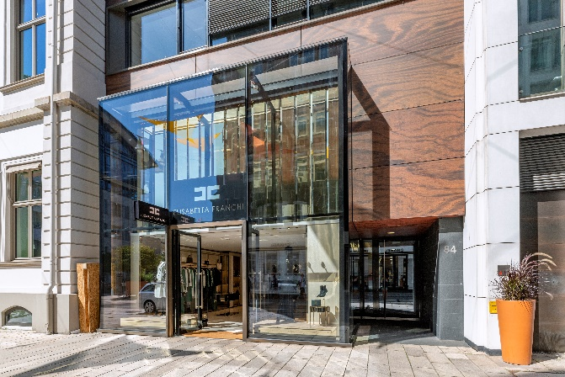 | Photo:  Elisabetta Franchi, an Italian prêt-à-porter brand for ladies’ fashion, opened at Neuer Wall 84 in July 2022. The mono-brand store is situated near the HafenCity end of the luxury shopping street.  Source of image: Jörg Bucher / Grossmann & Berger GmbH
About Grossmann & Berger
Grossmann & Berger GmbH is one of the leading service providers in the business of selling and letting commercial and residential properties in North Germany. Including its main office in Hamburg, the Company has 22 regional offices. This allows Grossmann & Berger to cover the entire North German market. In May 2021 the company was augmented by E & G Real Estate and
E & G Private Immobilien, so that Grossmann & Berger also operates in the two South German metropolitan areas of Stuttgart and Munich. Drawing on their comprehensive expertise in the real estate business, some 240 employees provide the full range of relevant services. They also benefit from the company’s more than 85 years standing in the industry. Grossmann & Berger belongs to the HASPA Group and is a founding member of the national commercial real estate network German Property Partners (GPP).

Please consult our website for Grossmann & Berger’s data privacy policy. Here you will also be able to access our press kit and the associated Terms of Use. If in future you would prefer not to receive any more information from our press office please e-mail us at presse@grossmann-berger.de quoting as reference "Abmeldung aus Presseverteiler” / “Unsubscribe from press mailing list”.

