Hamburg and the environs: Market survey pre-built residential properties 2022/2023
- Price reductions to average as much as six percent in 2023
- “New market conditions result in far greater need for consultancy”

Hamburg, 13 December 2022 – New interest rates, energy crisis, rocketing ancillary housing costs, shortages of materials - Hamburg’s market for residential properties was hit by several pieces of bad news in 2022. The altered parameters will most likely remain in place in 2023. Therefore Grossmann & Berger expects that next year standard houses* and apartments** (see definitions below) already built in Hamburg or its environs will cost between 2.9 % and 5.6 % less. However, this year prices have already fallen more dramatically. A summary of market details and forecasts may be found in the new ‘G&B Market survey of residential properties 2022/2023 Hamburg and the environs’.

Energy performance rating is buyers’ prime concern
“Despite reductions, the average price of a pre-built home in 2023 will be higher than in 2019,” says Andreas Gnielka, managing director of Grossmann & Berger. Due to the massive rise in energy costs, in Hamburg’s environs it is especially hard to sell big houses with a low efficiency rating. During the Covid pandemic these houses saw the biggest price increases and accordingly their prices are falling by the highest amount, 5.6 %. A similar development may be observed in the peripheral parts of the city. In further differentiation Gnielka adds that, “The prices for existing properties in need of work to make them more energy efficient and located in places inadequately served by public transport could fall by as much as 35 per cent by the end of the coming year. In view of the changes on the market, a property’s energy performance is no longer a secondary consideration but a prime purchase criterion.” Only in premium waterside locations by the Alster and Elbe are prices more or less stable. Since fewer people are in a position to buy such properties, prospective new owners have more scope to negotiate prices.

More opportunities to buy real estate
“Since this spring, there has been far more choice than in previous years. This situation will remain unchanged in 2023, and buyers with deep pockets will be at a particular advantage,” says Gnielka. However, the new environment also means that an entire segment of potential buyers has been squeezed out of the market: families that, up until the start of the year, were able to afford a small row house in the environs or on the edge of the city now find themselves unable to obtain a bank loan for their purchase. Altered parameters have meant that pre-built real estate, even when priced at fair market value, tends to be on the market for six months until sold, whereas the normal selling time used to be less than three months.

Estate agents are closing the current information gap
“Naturally, owners and potential buyers find the situation unsettling. Therefore they feel a greater need for consultancy services,” remarks Gnielka, speaking for his team. Because, unlike 2021, the asking prices on online portals are vastly different from the finally agreed purchase prices, a survey of these websites and the figures supplied by the Real Estate Evaluation Committees (Guterachterausschüsse) are not a true reflection of the market’s present state. “We, the actors on the market, immediately register all changes and can close the information gap.”

G&B Property Price Trend:
Assessment of the attainable prices for standard properties, well constructed and fitted out, in good residential neighbourhoods:
* Standard single family house: detached, with cellar, at least 130m² of living space, plot size typical for the location
** Standard condominium: vacant, 3 rooms, around 80 m² living space, 1st upper floor, lift (elevator), fitted kitchen
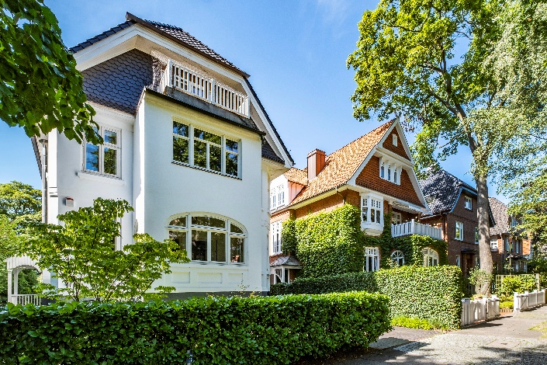 | Photo:  It is especially hard to sell big houses with a low energy efficiency rating in view of current energy costs.  Source of image: Arnt Haug / Grossmann & Berger GmbH

The Market survey for pre-built residential properties in Hamburg and the environs 2022/2023 is available to download from our website (in German only).

About Grossmann & Berger
Grossmann & Berger GmbH is one of the leading service providers in the business of selling and letting commercial and residential properties in North Germany. Including its main office in Hamburg, the Company has 22 regional offices. This allows Grossmann & Berger to cover the entire North German market. In May 2021 the company was augmented by E & G Real Estate and
E & G Private Immobilien, so that Grossmann & Berger also operates in the two South German metropolitan areas of Stuttgart and Munich. Drawing on their comprehensive expertise in the real estate business, some 240 employees provide the full range of relevant services. They also benefit from the company’s more than 85 years standing in the industry. Grossmann & Berger belongs to the HASPA Group and is a founding member of the national commercial real estate network German Property Partners (GPP).

Please consult our website for Grossmann & Berger’s data privacy policy. Here you will also be able to access our press kit and the associated Terms of Use. If in future you would prefer not to receive any more information from our press office please e-mail us at presse@grossmann-berger.de quoting as reference "Abmeldung aus Presseverteiler” / “Unsubscribe from press mailing list”.

