Hamburg: Office letting market 1st-4th quarters of 2022
Weak close to a strong year of office letting

Hamburg, 4 January 2023 – Between January and the end of September the letting business was very brisk, and several companies, such as Dataport, Haspa Bank and VTG signed agreements for extensive amounts of space. Because other firms were actively seeking large office suites, the estate agency sector was optimistic in autumn that 2022 would set a new record. However, in posting take-up of 100,000 m² the 4th quarter fell far below expectations. Nevertheless, the business of letting offices in Hamburg closed 2022 with a very good result that was 15 % higher than in 2021. Latest figures from Grossmann & Berger (G&B), member of German Property Partners (GPP), show total take-up for the year at 565,000 m². This was 8 % higher than the ten-year average (from 2013 to 2022) of 522,000 m². “Several firms requiring large amounts of space were unable to conclude an agreement in the fourth quarter and will continue negotiations in 2023. These uncompleted deals lead us to expect the year to start vigorously,” forecasts the spokesperson for the G&B management board, Andreas Rehberg.

Market details:
- In 2022 there were 19 large-volume agreements for offices in Hamburg, compared with eleven in 2021. Their share of the total volume was around 36 %. The agreements signed by Dataport and Haspa for large amounts of space were the two biggest of the year and the second and third-largest ever seen in Hamburg.
- Typically for Hamburg, the take-up of space was fairly evenly divided across all sectors of industry. Primarily due to the Dataport agreement, the IT sector was strongly represented, with 18 % of total take-up.
- “Many companies took care in 2022 to secure top premises in excellent locations,” remarks Rehberg. “They are thus able to offer their employees an attractive working environment and improve their chance of winning the battle for skilled personnel.” Therefore 23 agreements fell into the rental price segment of €30/m²/month, significantly more than in 2021 when the total was six.
- By the end of the year both the average rent, weighted by area, and the premium rent remained settled at a high level The average rent might fall slightly in 2023 when more mid-sized companies start to look for premises. In general they are rather more price-conscious.
- Letting was concentrated in the City and HafenCity sub-markets. Year on year these two top locations increased their share of the market from 34 % to 43 %. City South’s share of take-up rose to 15 % as this less expensive location also offered many properties of new-build standard (2021: 11 %).
- The short-term supply of available space grew by 4.4 % year on year and is set to increase further during the year. The volume of new-build completions is likely to peak in 2023. “In the medium term construction activity will lessen. Developers will erect fewer buildings on speculation in view of the difficult business environment caused by shortages of materials and the high costs of construction and borrowing. A relatively high pre-let ratio will then become the general rule,” predicts Rehberg.
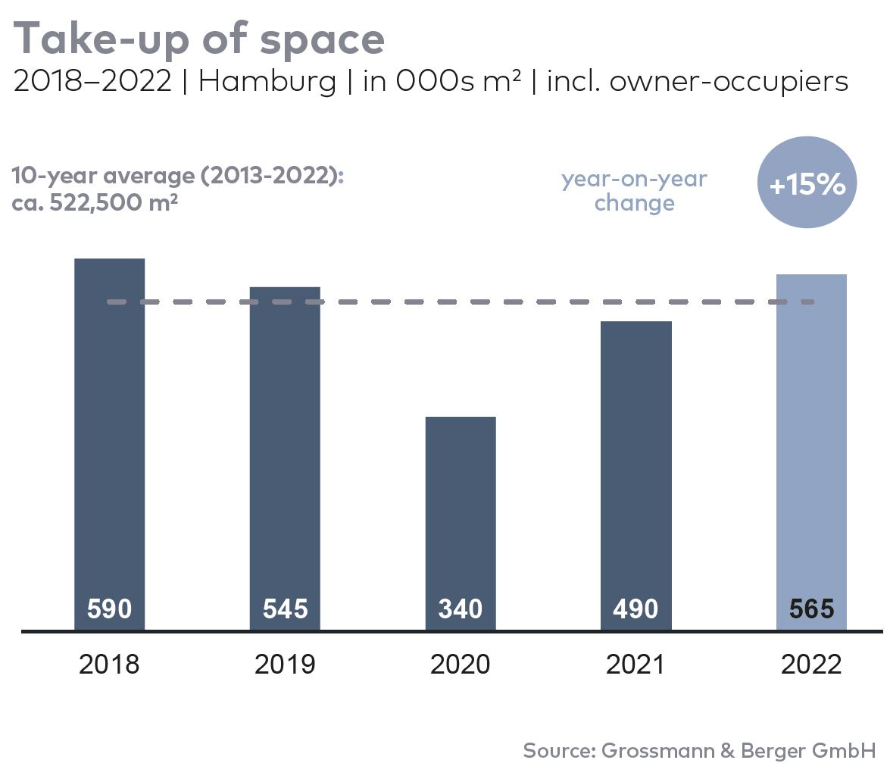
Office letting market | Hamburg | 2022 | Q1-4
Space take-up [m²] | 565,000
against prior yr [%] | +15.3
Premium rent [€/m²/month net of services] | 33.50
against prior yr [%] | +6.3
Average rent [€/m²/month net of services] | 21.00
against prior yr [%] | +16.0
Stock of office space [millions m²] | 14.1
Vacant space incl. sub-let space [m²] | 561,200
against prior yr [%] | +4.4
Vacancy rate incl. sub-let space [%] | 4.0
Completions 2023+2024 [m²] | 440,000
Pre-let ratio [%] | 65

Top selected known agreements | offices in Hamburg | Q1-4 2022
Tenant/owner-occupier | Property/project | Street no. | Sub-market | Rental area  [ca. m²]
Dataport | “Hanse Center” | Wikingerweg 1, Normannenweg 25, 27, 29, Eiffestrasse 26, 28, 30 | City South | 40,000
Hamburger Sparkasse | “Deutschlandhaus” | Dammtorstrasse 1 | City | 30,800
VTG | “Green Innovation Lab” | Versmannstrasse, “Elbbrückenquartier” | HafenCity | 11,500
Kasse.Hamburg | Existing building | Gasstrasse 27 | Bahrenfeld | 8,900
Reemtsma | “Marzipanfabrik” | Jürgen-Töpfer-Strasse 50 | Altona | 8,100

Transactions occurring in the quarter covered by this report are highlighted.

The Market survey office letting in Hamburg 2022/Q4 will soon be available to download from our website.

About Grossmann & Berger
Grossmann & Berger GmbH is one of the leading service providers in the business of selling and letting commercial and residential properties in North Germany. Including its main office in Hamburg, the Company has 22 regional offices. This allows Grossmann & Berger to cover the entire North German market. In May 2021 the company was augmented by E & G Real Estate and
E & G Private Immobilien, so that Grossmann & Berger also operates in the two South German metropolitan areas of Stuttgart and Munich. Drawing on their comprehensive expertise in the real estate business, some 240 employees provide the full range of relevant services. They also benefit from the company’s more than 85 years standing in the industry. Grossmann & Berger belongs to the HASPA Group and is a founding member of the national commercial real estate network German Property Partners (GPP).

Please consult our website for Grossmann & Berger’s data privacy policy. Here you will also be able to access our press kit and the associated Terms of Use. If in future you would prefer not to receive any more information from our press office please e-mail us at presse@grossmann-berger.de quoting as reference "Abmeldung aus Presseverteiler” / “Unsubscribe from press mailing list”.

