Hamburg: Office letting market 1st quarter of 2023
Many queries from the Mittelstand

Hamburg, 4 April 2023 – The office letting market in Hamburg started the year 2023 with take-up of space at a respectable 105,000 m². Nevertheless, the result posted for the 1st quarter of 2023 was 22 % below the strong take-up of space in the same quarter a year before. Research conducted by Grossmann & Berger, member of German Property Partners (GPP), reveals that relatively little space was taken up by owner-occupiers as well as by tenants of space measuring between 1,000 and 2,000 m². “Despite all, the mood is good,” remarks Andreas Rehberg, spokesperson for the Grossmann & Berger management board. “At present many companies in the Mittelstand are enquiring about premises offering up to 5,000 square metres of space. Irrespective of size category, potential occupiers are consistently seeking offices in good locations with excellent fit-out. Sustainability issues have now definitely become one of the search criteria, ESG conformity is growing more and more important when deciding which property to rent.”

Market details:
- At the start of the year owner-occupiers played a negligible role with take-up of around 3,000 m². Year on year their share of take-up on Hamburg’s office market fell from 16 % to 3 % in the 1st quarter of 2023.
- Whereas take-up of space in the size category of over 2,000 m² was relatively unchanged year on year at some 50,900 m², appreciably less space was taken up in the smaller segment, i.e. below 2,000 m². Take-up of space in this category fell by 33 %.
- In view of several rental agreements signed over the past twelve months for prime new-build projects such as the “Burstah” or “Westfield Hamburg-Überseequartier”, the premium rent has climbed to a new record high of €34.50/m²/month. The average rent has remained stable since the 3rd quarter of 2022 at €21.00/m²/month.
- Rehberg notes that, “With a vacancy rate of 4 per cent in Hamburg we have now regained a healthy relationship between supply and demand.” At the beginning of 2022 the vacancy rate had been 3.5 %. Year on year the supply of sub-let space available in the short term has decreased a little. “Some firms are, however, receptive to the idea of moving into smaller premises. But it is important to find the right solutions for all parties,” says Rehberg, commenting the changing availability of sub-let space.
- He adds that, “Delays in construction projects led to shifts in the volume of completions.” At the end of March the total completions for 2023 and 2024 added up to 395,000 m², of which 74 % has been pre-let. Only a few speculative projects were started in view of the pre-letting ratios required by the lending banks.
- Partly due to the two biggest rental agreements signed, educational facilities and the information and telecom sectors of industry each took a 12 % share of the market.

Office letting market | Hamburg | 2023 | Q1
Space take-up [m²] | 105,000
against prior yr [%] | -22.2
Premium rent [€/m²/month net of services] | 34.50
against prior yr [%] | +9.5
Average rent [€/m²/month net of services] | 21.00
against prior yr [%] | +13.5
Stock of office space [millions m²] | 14.16
Vacant space incl. sub-let space [m²] | 563,100
against prior yr [%] | +14.2
Vacancy rate incl. sub-let space [%] | 4.0
Completions 2023+2024 [m²] | 395,000
Pre-let ratio [%] | 74
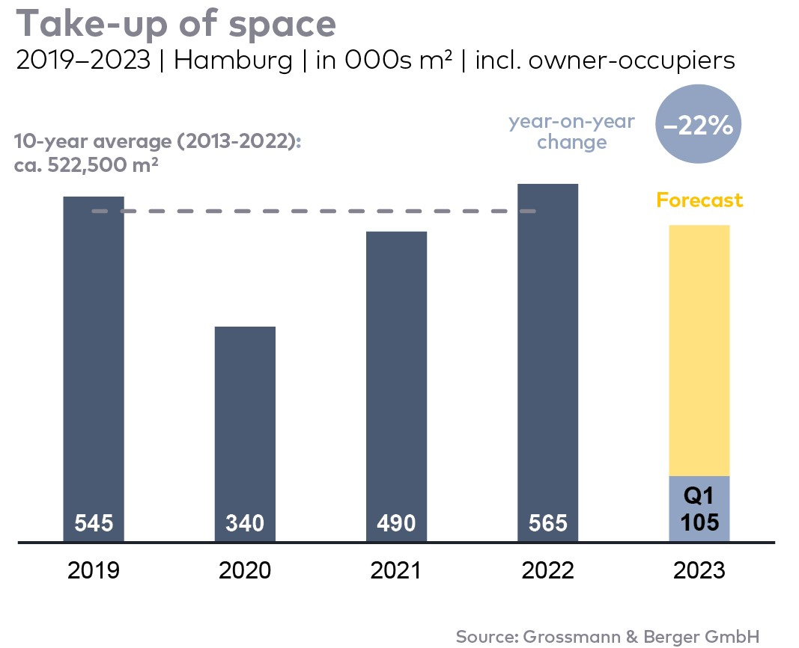

Top selected known agreements | offices in Hamburg | Q1 2023
Tenant/owner-occupier | Property/project | Street no. | Sub-market | Rental area  [ca. m²]
Educational facility | “Zeughaus” | Christoph-Probst-Weg 26-31 | Eppendorf | 6,750
Telefonica Germany | “Tichelhaus” | Willy-Brandt-Strasse 69 | City | 6,700
Manufacturing /industrial/craft trades | confidential | confidential | Hamburg North-East | 6,160

The Market report office letting in Hamburg 2023/Q1 will soon be available to download from our website.

About Grossmann & Berger
Grossmann & Berger GmbH is one of the leading service providers in the business of selling and letting commercial and residential properties. Including its headquarters in Hamburg and locations in Berlin, Stuttgart and Munich, the group of companies consisting of Grossmann & Berger and E & G Immobilien has 22 local offices throughout Germany. Drawing on their comprehensive expertise in the real estate business, some 250 employees provide the full range of relevant services. They also benefit from the company’s more than 90 years standing in the industry. Grossmann & Berger belongs to HASPA Group and is a founding member of the national commercial real estate network German Property Partners (GPP).

Please consult our website for Grossmann & Berger’s data privacy policy. Here you will also be able to access our press portfolio and the associated terms of use. If in future you would prefer not to receive any more information from our press office please e-mail us at presse@grossmann-berger.de quoting as reference "Abmeldung aus Presseverteiler” / “Unsubscribe from press mailing list”.

