Hamburg: Office letting market, 1st-2nd quarters or 2022
Agreements for new-build space lead to record increase in average rent

Hamburg, 5 July 2022 — With transactions up by more than a third year on year, Hamburg posted a total of 305,000 m² of newly let office space between January and June 2022, a half-year result that is second only to the 310,000 m² recorded in 2019. 170,000 m² of office space was taken up in the 2nd quarter. “Many firms and public sector employers have now determined what kind of offices they need for their forward-looking work environments and are now deciding on the appropriate rental space. That has provided a boost to the market for offices in Hamburg,” says Andreas Rehberg, spokesperson for the management board of the GPP-member firm Grossmann & Berger in his analysis. However, the war in Ukraine, disrupted supply chains, rising inflation and, in particular, the looming energy crisis pose risks to the economy and thus to the business of office letting. Despite this, so many clients are enquiring about office space that it seems likely that the closing total for the year could reach 550,000 m², on a par with the pre-crisis year of 2019.

Market details:
- 13 leases for premises of more than 5,000 m² were signed, compared with seven a year ago. This segment of the market thus comprised 39 % of take-up by the end of June. No other size category accounted for more than 20 % of the total. Two agreements for more than 10,000 m² were noted; in the first half of 2021 three such contracts were signed.
- In May the Haspa (a bank) announced it was leasing 30,800 m² in the “Deutschlandhaus” in order to merge offices now occupied at Adolphsplatz, Wikingerweg and Börsenbrücke. This was the largest transaction of the year to date.
- “Most firms are looking for new-build space in central parts of Hamburg. Consequently, three quarters of office suites sized between 2,000 and 5,000 square metres were taken off-plan or in refurbished properties for correspondingly high rents,” says Rehberg, summarizing the situation.
- This trend explains the enormous leap in average rents, which climbed 15 % to €20.60/m²/month. For the first time ever, the average monthly rent has passed the €20/m² mark. Growth of some 5 % also pushed the premium rent to a new high of €32.50/m²/month.
- In view of the popularity of central locations, market activity was concentrated in the City and HafenCity sub-markets, which posted 35 % and 21 % of total take-up respectively. No other sub-market reached a two-figure share of the market. Nine of the 13 biggest agreements for more than 5,000 m² of space were noted in these two sub-markets.
- The vacancy rate is unchanged year on year at 3.8 %. Rehberg is confident that, “Considering that the pre-let ratio is 76 per cent for scheduled completions in 2022 and 2023 and that demand is obviously high, the market can easily absorb office buildings under construction, so there will be no significant rise in empty space in the new-build sector.” However, the latest calculations show that more space in existing buildings could become vacant within the next twelve months and drive up the vacancy rate to over 4 %.
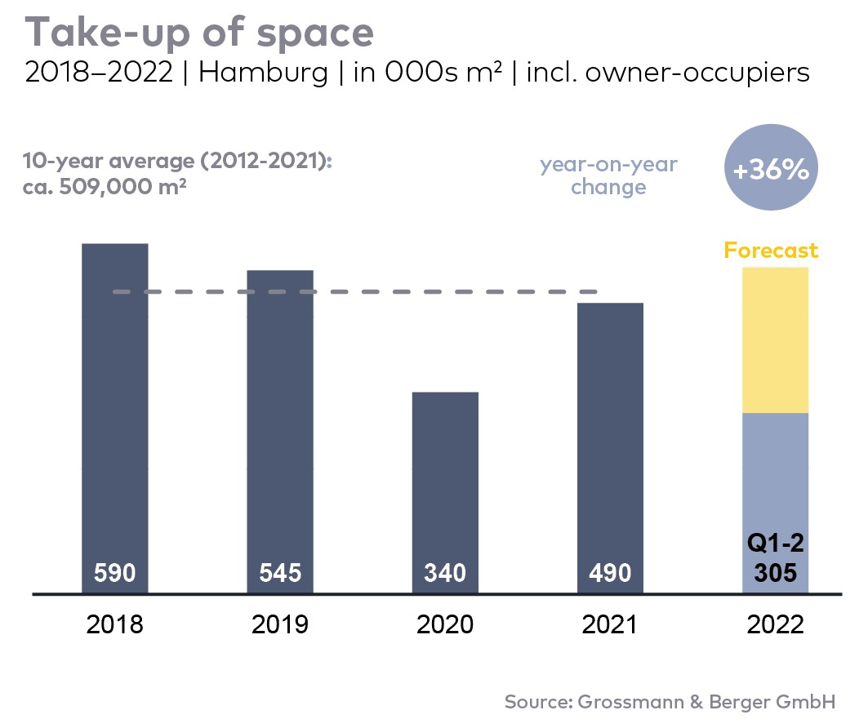
Office letting market | Hamburg | 2022 | Q1-2
Space take-up [m²] | 305,000
against prior yr [%] | +35.6
Premium rent [€/m²/month net of services] | 32.50
against prior yr [%] | +4.8
Average rent [€/m²/month net of services] | 20.60
against prior yr [%] | +15.1
Stock of office space [millions m²] | 14.0
Vacant space incl. sub-let space [m²] | 525,500
against prior yr [%] | -1.8
Vacancy rate incl. sub-let space [%] | 3.8
Completions 2022+2023 [m²] | 549,000
Pre-let ratio [%] | 76

Top selected known agreements | offices in Hamburg | Q1-2 2022
Tenant/owner-occupier | Property/project | Street no. | Sub-market | Rental area  [ca. m²]
Hamburger Sparkasse | “Deutschlandhaus” | Dammtorstrasse 1 | City | 30,800
VTG | “Green Innovation Lab” | Versmannstrasse, “Elbbrückenquartier” | HafenCity | 11,500
Kasse.Hamburg | Existing building | Gasstrasse 27 | Bahrenfeld | 8,900
Construction and real estate sector | “Spiegel Haus” | Ericusspitze 1 | HafenCity | 7,800
Retail sector | “Herrlichkeit” | Rödingsmarkt 16 | City | 7,600

Transactions occurring in the quarter covered by this report are highlighted.

The market survey office letting Hamburg 2022/Q2 will soon be available to download from our website.

About Grossmann & Berger
Grossmann & Berger GmbH is one of the leading service providers in the business of selling and letting commercial and residential properties in North Germany. Including its main office in Hamburg, the Company has 22 regional offices. This allows Grossmann & Berger to cover the entire North German market. In May 2021 the company was augmented by E & G Real Estate and
E & G Private Immobilien, so that Grossmann & Berger also operates in the two South German metropolitan areas of Stuttgart and Munich. Drawing on their comprehensive expertise in the real estate business, some 240 employees provide the full range of relevant services. They also benefit from the company’s more than 85 years standing in the industry. Grossmann & Berger belongs to the HASPA Group and is a founding member of the national commercial real estate network German Property Partners (GPP).

Please consult our website for Grossmann & Berger’s data privacy policy. Here you will also be able to access our press kit and the associated Terms of use. If in future you would prefer not to receive any more information from our press office, please e-mail us at presse@grossmann-berger.de quoting as reference "Abmeldung aus Presseverteiler” / “Unsubscribe from press mailing list”.

