Hamburg: Office letting market, 1st-3rd quarters of 2022
Potential tenants are recognizably less price sensitive

Hamburg, 5 October 2022 – Very brisk business on the market for office lets in Hamburg generated a year on year increase in take-up of around 30 % by the end of September. Just two of the year’s biggest agreements, signed by Dataport and Haspa bank, together accounted for 70,000 m² of space. Latest figures from Grossmann & Berger, member of German Property Partners (GPP), show a total for the year to date of 465,000 m². At the end of the 3rd quarter, Hamburg’s office letting business had thus reached a level seen in the record year 2017. The high volume of space let in new or good as new buildings (+54 % year on year) pushed premium and average rents to new highs. “In the struggle to attract qualified staff, employers have become noticeably less price sensitive; increasingly, firms seek and rent top quality office space in central locations,” says Andreas Rehberg, spokesperson for the G&B management board. “At the moment some companies are still looking for large premises and agreements could be concluded before the close of 2022. It is therefore realistic to believe that the final total for the year will be 600,000 square metres of take-up. Moreover, a growing number of firms in Germany’s “Mittelstand” are also starting the search for new office space. Therefore, despite the many risks facing the economy, the market’s momentum is likely to continue and carry over into next year.”

Market details:
- To date, large-volume agreements, i.e. those for more than 5,000 m², have dominated the market. Year on year the number of such contracts increased from ten to 18, the volume more than doubled. Their share of the total volume was around 40 %. “Due to the agreement signed by Dataport, companies from the information and telecommunications sector of industry took the largest share of the market – 19 per cent. At 40,030 square metres, it also represented the third-largest office let so far registered in Hamburg,” remarks Rehberg.
- At the end of the 3rd quarter 31 % of all space let was in the rental price category > €25.00/m²/month whereas a year ago 6 % fell into this bracket. During the same period, the proportion of agreements for space costing > €30/m²/month rose from 1 to 11 %.
- Therefore, the average rent, weighted by area let, rose by 16 % to a new high of €21.00/m²/month. Short supply has driven the premium rent up by 6 % to a new high of €33.50/m²/month.
- Together, the sub-markets City and HafenCity accounted for 47 % of take-up compared with 31 % at the end of the 3rd quarter of 2021. “In both of these two major sub-markets there are many development projects which offer exactly what tenants are currently seeking, such as the ‘Deutschlandhaus’ in City or the ‘Westfield Hamburg-Überseequartier in HafenCity district”, remarks Rehberg.
- Although the total stock of office space was slightly higher, the vacancy rate remained unchanged year on year at 3.8 %. The amount of space standing empty will probably grow a little over the next twelve months. New-build completions in Hamburg are likely to peak in 2023 at 317,000 m². 75 % of this space has been pre-let, some 78,000 m² are being built on speculation.
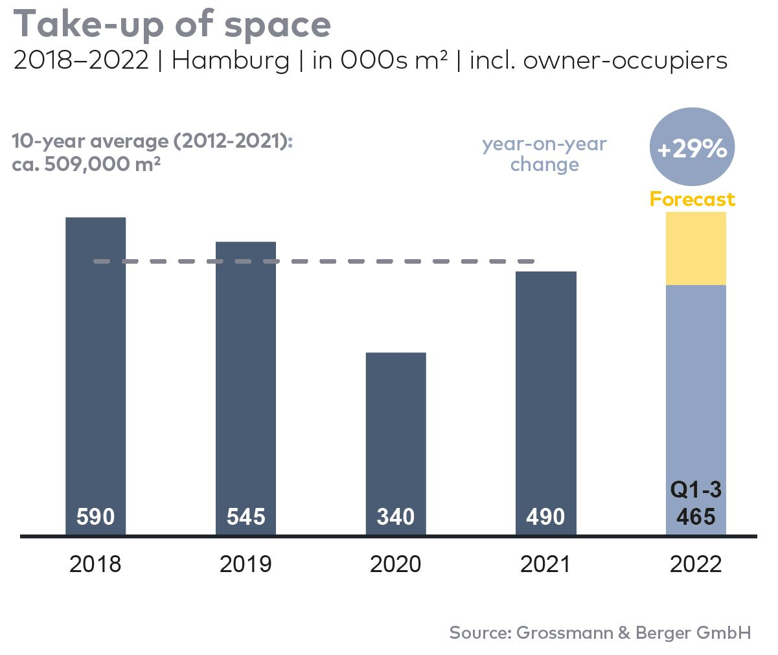
Office letting market | Hamburg | 2022 | Q1-3
Space take-up [m²] | 465,000
against prior yr [%] | +29.2
Premium rent [€/m²/month net of services] | 33.50
against prior yr [%] | +6.3
Average rent [€/m²/month net of services] | 21.00
against prior yr [%] | +16.0
Stock of office space [millions m²] | 14.1
Vacant space incl. sub-let space [m²] | 541,900
against prior yr [%] | +1.0
Vacancy rate incl. sub-let space [%] | 3.8
Completions 2022+2023 [m²] | 511,000
Pre-let ratio [%] | 77

Top selected known agreements | offices in Hamburg | Q1-3 2022
Tenant/owner-occupier | Property/project | Street no. | Sub-market | Rental area  [ca. m²]
Dataport | “Hanse Center” | Wikingerweg 1, Normannenweg 25, 27, 29, Eiffestrasse 26, 28, 30 | City South | 40,000
Hamburger Sparkasse | “Deutschlandhaus” | Dammtorstrasse 1 | City | 30,800
VTG | “Green Innovation Lab” | Versmannstrasse, “Elbbrückenquartier” | HafenCity | 11,500
Kasse.Hamburg | Existing building | Gasstrasse 27 | Bahrenfeld | 8,900
Reemtsma | “Marzipanfabrik” | Jürgen-Töpfer-Strasse 50 | Altona | 8,100

Transactions occurring in the quarter covered by this report are highlighted.

The Market survey office letting Hamburg 2022/Q1-3 will soon be available to download from our website.

About Grossmann & Berger
Grossmann & Berger GmbH is one of the leading service providers in the business of selling and letting commercial and residential properties in North Germany. Including its main office in Hamburg, the Company has 22 regional offices. This allows Grossmann & Berger to cover the entire North German market. In May 2021 the company was augmented by E & G Real Estate and
E & G Private Immobilien, so that Grossmann & Berger also operates in the two South German metropolitan areas of Stuttgart and Munich. Drawing on their comprehensive expertise in the real estate business, some 240 employees provide the full range of relevant services. They also benefit from the company’s more than 85 years standing in the industry. Grossmann & Berger belongs to the HASPA Group and is a founding member of the national commercial real estate network German Property Partners (GPP).

Please consult our website for Grossmann & Berger’s data privacy policy. Here you will also be able to access our press kit and the associated Terms of use. If in future you would prefer not to receive any more information from our press office please e-mail us at presse@grossmann-berger.de quoting as reference "Abmeldung aus Presseverteiler” / “Unsubscribe from press mailing list”.

