Hamburg: Residential | Buy-to-let investments 2022 / 2023
New interest rates halt price rises on the buy-to-let market

Hamburg, 8th September 2022 – Demand for buy-to-let housing investments in Hamburg has cooled in view of increasing borrowing costs. “Whereas investors are waiting for prices to come down, sellers are not yet prepared to adjust their asking prices to reflect the changing market. Therefore fewer transactions are taking place and the market is undergoing a shakeout,” reports Sandra Ludwig, managing director of Grossmann & Berger, a member of German Property Partners (GPP). The high rate of inflation, increased construction costs, the shortage of skilled workers and the Ukraine war with its massive impact on supplies of commodities and energy are also weighing on the market. The dynamic growth of prices in recent years has thus come to a halt. Depending on location, the real estate trade expects property prices in Hamburg to drop by between 10 and 20 % compared with the records set in 2021.

Grossmann & Berger has compiled forecasts on how the Hamburg market for rental housing will develop in 2023 in its market survey of “Residential | Investment Properties 2022/2023 Hamburg”.

Price/earnings ratios and square-metre prices updated for 2022
In view of the changed market conditions, Grossmann & Berger have revised their forecast for 2022 on the price/earnings ratios* for standard properties**. The maximum p/e ratio for real estate in absolutely premium parts of the districts near the Alster Lake is set to fall back during the year to 42 times the annual net rental charge. Last year the ratio was 45. The minimum ratio, applicable to real estate in less desirable locations south of the Elbe, is expected to fall to a multiple of 20 in 2022, down from 23 in 2021. The maximum ratio would thus be equivalent to that seen in 2020, the minimum ratio to that noted in 2018. Grossmann & Berger has also revised the forecast for square-metre prices of buy-to-let housing during the current year: the maximum purchase price for standard properties** is likely to slip back 2 % against 2021 to €6,500/m². Grossmann & Berger expects a more significant decline in the minimum purchase price, which is set to drop by €400/m² to €2,100/m².

Prices expected to stabilize at their current level in 2023
The G&B Real Estate Price Trend suggests that price/earnings ratios and square-metre prices will stabilize at their current level in the year ahead, provided that there are no further swings in mortgage interest rates. The challenging market conditions also open up new opportunities for the business of buying houses to rent out; as Ludwig explains, “Many people who would like to buy can no longer afford the increased cost of borrowing. If they nevertheless wish to improve their accommodation, they are now more likely to look for a rental apartment, which pushes up demand in this sector of the market.” The declining volume of building completions and the high cost of construction will, in the medium term, also affect prices for housing. “All in all, these aspects lead us to expect that in the long term there will be further increases in the price of buy-to-let real estate,” predicts Ludwig.

* Price/earnings ratio: quotient of the purchase price divided by annual net rent, equivalent to the gross initial yield.

** Standard property: Property in a normal state of repair (not a new build) containing at least five residential units and fully let at customary market rates.

The detailed survey may be downloaded from our Website.

Materials

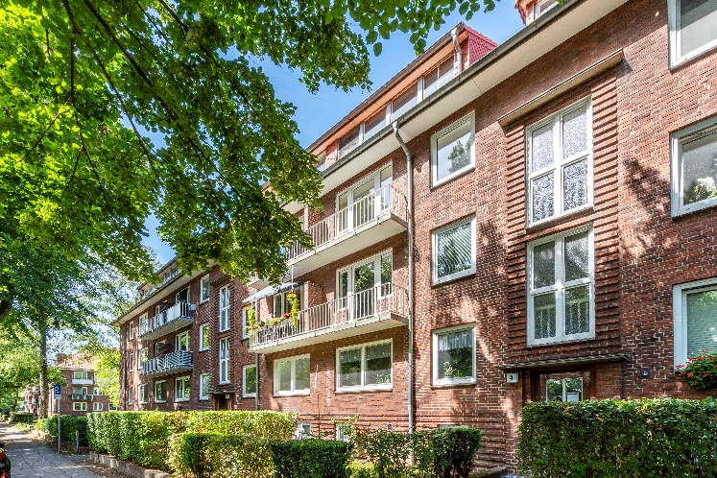
Photo:

An apartment block with 21 units in Fühlsbüttel which the buy-to-let housing team at G&B brokered for a price 38 times the annual net rent excluding service charges.

Source of image: Jenner-Egberts GbR Fotografie / Grossmann & Berger

About Grossmann & Berger
Grossmann & Berger GmbH is one of the leading service providers in the business of selling and letting commercial and residential properties in North Germany. Including its main office in Hamburg, the Company has 22 regional offices. This allows Grossmann & Berger to cover the entire North German market. In May 2021 the company was augmented by E & G Real Estate and
E & G Private Immobilien, so that Grossmann & Berger also operates in the two South German metropolitan areas of Stuttgart and Munich. Drawing on their comprehensive expertise in the real estate business, some 240 employees provide the full range of relevant services. They also benefit from the company’s more than 85 years standing in the industry. Grossmann & Berger belongs to the HASPA Group and is a founding member of the national commercial real estate network German Property Partners (GPP).

Please consult our website for Grossmann & Berger’sdata privacy policy Here you will also be able to access our press kit and the associated Terms of Use. If in future you would prefer not to receive any more information from our press office please e-mail us at presse@grossmann-berger.de quoting as reference "Abmeldung aus Presseverteiler” / “Unsubscribe from press mailing list”.

